figs_tabs_results

#Geographical distribution of reference streamgauging stations ##Statistics for paper - Number of gauges in total: 5355  
- Number of perennial gauges used in analysis (average number of years of data): 3967(gpredsdt[intermittent_o1800==0, mean(totalYears_kept_o1800)]) - Number of intermittent gauges taking in account only post-1800, mDur >= 1 (average number of years of data): 1388(34.2067723) - Number of intermittent gauges taking in account only post-1800, mDur > 0 (average number of years of data): 1719 - Number of intermittent gauges taking in account only post-1800, mDur >= 30 (average number of years of data): 1005

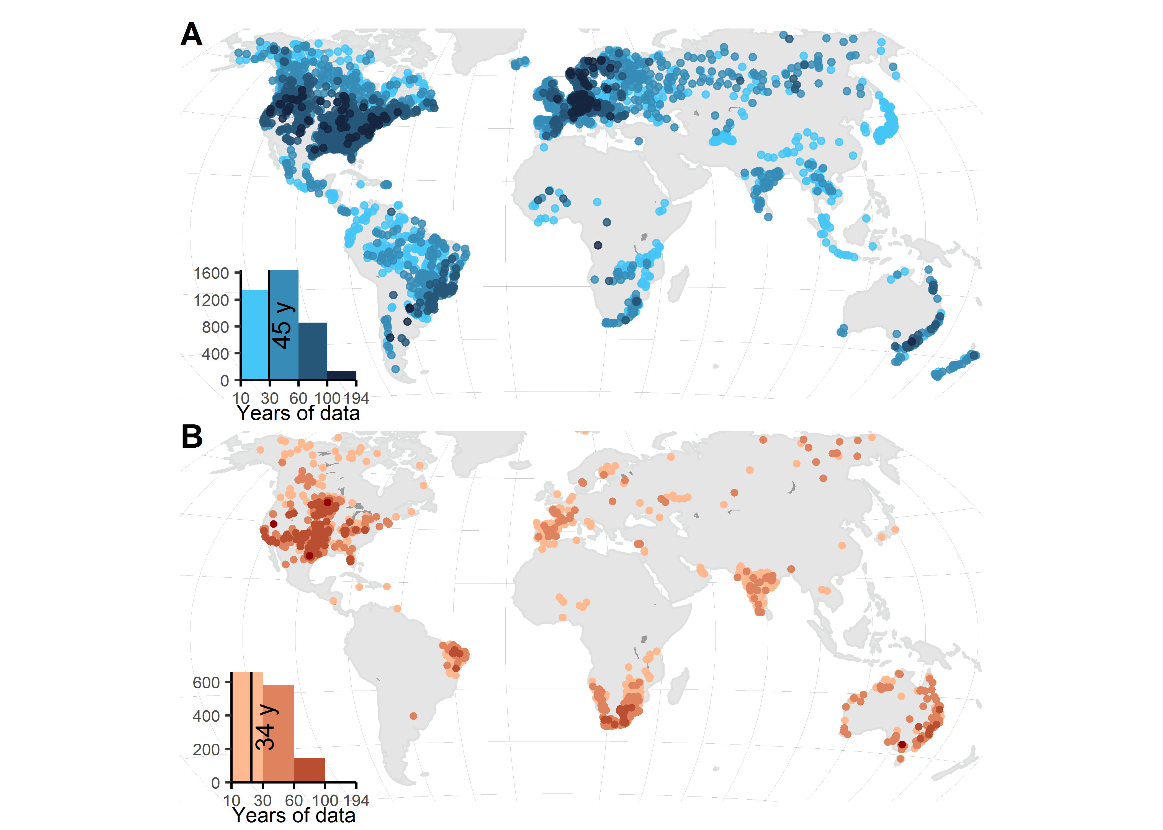

#WaterGAP stats

| bin | bin_lformat | pearsonr | mae | smape | rsq | rsq_nooutliers | n_total | noutliers | comp |
| --- | --- | --- | --- | --- | --- | --- | --- | --- | --- |
| 1 | 0.00602527125394863-0.998196798989154 | 0.366 | 0.65 | 0.76 | 0.134 | 0.134 | 210 | 0 | qmean_dism3pyr |
| 2 | 1.0007539697025-9.9390595878591 | 0.329 | 2.57 | 0.44 | 0.109 | 0.246 | 576 | 1 | qmean_dism3pyr |
| 3 | 10.0640810366855-99.8094527363184 | 0.835 | 9.47 | 0.26 | 0.696 | 0.732 | 926 | 3 | qmean_dism3pyr |
| 4 | 101.061685786802-959.93408115772 | 0.959 | 35.50 | 0.13 | 0.919 | 0.946 | 489 | 3 | qmean_dism3pyr |
| 5 | 1016.02701834276-9527.07653850732 | 0.994 | 142.06 | 0.06 | 0.987 | 0.993 | 142 | 3 | qmean_dism3pyr |
| 6 | 10057.3830496369-181046.42452563 | 0.999 | 1390.08 | 0.04 | 0.998 | 0.999 | 20 | 1 | qmean_dism3pyr |
| 7 | all | 0.999 | 32.04 | 0.31 | 0.956 | 0.958 | 2363 | 3 | qmean_dism3pyr |
| 1 | 0.00602527125394863-0.998196798989154 | 0.153 | 0.25 | NaN | 0.023 | 0.023 | 210 | 0 | q90_dism3mn |
| 2 | 1.0007539697025-9.9390595878591 | 0.229 | 1.43 | NaN | 0.052 | 0.085 | 576 | 3 | q90_dism3mn |
| 3 | 10.0640810366855-99.8094527363184 | 0.459 | 9.89 | 0.85 | 0.210 | 0.203 | 926 | 2 | q90_dism3mn |
| 4 | 101.061685786802-959.93408115772 | 0.679 | 67.94 | 0.63 | 0.461 | 0.513 | 489 | 3 | q90_dism3mn |
| 5 | 1016.02701834276-9527.07653850732 | 0.834 | 493.60 | 0.47 | 0.695 | 0.695 | 142 | 0 | q90_dism3mn |
| 6 | 10057.3830496369-181046.42452563 | 0.996 | 3044.20 | 0.27 | 0.991 | 0.986 | 20 | 2 | q90_dism3mn |
| 7 | all | 0.995 | 73.73 | NaN | 0.838 | 0.839 | 2363 | 1 | q90_dism3mn |

#Environmental variables used in model training + variable selection results

| Category | Attribute | Spatial representation | Temporal/Statistical aggreg. | Source | Citation |
| --- | --- | --- | --- | --- | --- |
| Physiography | Drainage Area | u |  | HydroSHEDS | Lehner & Grill 2013 |
| Hydrology | Natural Discharge | p | mn/mx | WaterGAP v2.2 | DÃ¶ll et al. 2003 |
| Hydrology | Natural Discharge | p | mn/yr | WaterGAP v2.2 | DÃ¶ll et al. 2003 |
| Physiography | Elevation | c | (cav-uav)/uav | EarthEnv-DEM90 | Robinson et al. 2014 |
| Hydrology | Groundwater table depth | c | av | Global Groundwater Map | Fan et al. 2013 |
| Hydrology | Runoff coefficient | c | yr | WaterGAP v2.2, WorldClim v2 | DÃ¶ll et al. 2003 |
| Hydrology | Specific discharge | u | mn | WaterGAP v2.2 | DÃ¶ll et al. 2003 |
| Hydrology | Specific discharge | u | yr | WaterGAP v2.2 | DÃ¶ll et al. 2003 |
| Climate | Actual Evapotranspiration | catchment | Annual average | Global Soil-Water Balance | Trabucco & Zomer 2010 |
| Climate | Actual Evapotranspiration | watershed | Annual average | Global Soil-Water Balance | Trabucco & Zomer 2010 |
| Climate | BIO1 - Annual Mean Temperature | catchment | Average | WorldClim v2 | Fick et al. 2017 |
| Climate | BIO1 - Annual Mean Temperature | watershed | Average | WorldClim v2 | Fick et al. 2017 |
| Climate | BIO10 - Mean Temperature of Warmest Quarter | catchment | Average | WorldClim v2 | Fick et al. 2017 |
| Climate | BIO10 - Mean Temperature of Warmest Quarter | watershed | Average | WorldClim v2 | Fick et al. 2017 |
| Climate | BIO11 - Mean Temperature of Coldest Quarter | catchment | Average | WorldClim v2 | Fick et al. 2017 |
| Climate | BIO11 - Mean Temperature of Coldest Quarter | watershed | Average | WorldClim v2 | Fick et al. 2017 |
| Climate | BIO12 - Annual Precipitation | catchment | Average | WorldClim v2 | Fick et al. 2017 |
| Climate | BIO12 - Annual Precipitation | watershed | Average | WorldClim v2 | Fick et al. 2017 |
| Climate | BIO13 - Precipitation of Wettest Month | catchment | Average | WorldClim v2 | Fick et al. 2017 |
| Climate | BIO13 - Precipitation of Wettest Month | watershed | Average | WorldClim v2 | Fick et al. 2017 |
| Climate | BIO14 - Precipitation of Driest Month | catchment | Average | WorldClim v2 | Fick et al. 2017 |
| Climate | BIO14 - Precipitation of Driest Month | watershed | Average | WorldClim v2 | Fick et al. 2017 |
| Climate | BIO15 - Precipitation Seasonality (Coefficient of Variation) | catchment | Average | WorldClim v2 | Fick et al. 2017 |
| Climate | BIO15 - Precipitation Seasonality (Coefficient of Variation) | watershed | Average | WorldClim v2 | Fick et al. 2017 |
| Climate | BIO16 - Precipitation of Wettest Quarter | catchment | Average | WorldClim v2 | Fick et al. 2017 |
| Climate | BIO16 - Precipitation of Wettest Quarter | watershed | Average | WorldClim v2 | Fick et al. 2017 |
| Climate | BIO17 - Precipitation of Driest Quarter | catchment | Average | WorldClim v2 | Fick et al. 2017 |
| Climate | BIO17 - Precipitation of Driest Quarter | watershed | Average | WorldClim v2 | Fick et al. 2017 |
| Climate | BIO18 - Precipitation of Warmest Quarter | catchment | Average | WorldClim v2 | Fick et al. 2017 |
| Climate | BIO18 - Precipitation of Warmest Quarter | watershed | Average | WorldClim v2 | Fick et al. 2017 |
| Climate | BIO19 - Precipitation of Coldest Quarter | catchment | Average | WorldClim v2 | Fick et al. 2017 |
| Climate | BIO19 - Precipitation of Coldest Quarter | watershed | Average | WorldClim v2 | Fick et al. 2017 |
| Climate | BIO2 - Mean Diurnal Range (Mean of monthly (max temp - min temp)) | catchment | Average | WorldClim v2 | Fick et al. 2017 |
| Climate | BIO2 - Mean Diurnal Range (Mean of monthly (max temp - min temp)) | watershed | Average | WorldClim v2 | Fick et al. 2017 |
| Climate | BIO3 - Isothermality (BIO2/BIO7) (×100) | catchment | Average | WorldClim v2 | Fick et al. 2017 |
| Climate | BIO3 - Isothermality (BIO2/BIO7) (×100) | watershed | Average | WorldClim v2 | Fick et al. 2017 |
| Climate | BIO4 - Temperature Seasonality (standard deviation ×100) | catchment | Average | WorldClim v2 | Fick et al. 2017 |
| Climate | BIO4 - Temperature Seasonality (standard deviation ×100) | watershed | Average | WorldClim v2 | Fick et al. 2017 |
| Climate | BIO5 - Max Temperature of Warmest Month | catchment | Average | WorldClim v2 | Fick et al. 2017 |
| Climate | BIO5 - Max Temperature of Warmest Month | watershed | Average | WorldClim v2 | Fick et al. 2017 |
| Climate | BIO6 - Min Temperature of Coldest Month | catchment | Average | WorldClim v2 | Fick et al. 2017 |
| Climate | BIO6 - Min Temperature of Coldest Month | watershed | Average | WorldClim v2 | Fick et al. 2017 |
| Climate | BIO7 - Temperature Annual Range (BIO5-BIO6) | catchment | Average | WorldClim v2 | Fick et al. 2017 |
| Climate | BIO7 - Temperature Annual Range (BIO5-BIO6) | watershed | Average | WorldClim v2 | Fick et al. 2017 |
| Climate | BIO8 - Mean Temperature of Wettest Quarter | catchment | Average | WorldClim v2 | Fick et al. 2017 |
| Climate | BIO8 - Mean Temperature of Wettest Quarter | watershed | Average | WorldClim v2 | Fick et al. 2017 |
| Climate | BIO9 - Mean Temperature of Driest Quarter | catchment | Average | WorldClim v2 | Fick et al. 2017 |
| Climate | BIO9 - Mean Temperature of Driest Quarter | watershed | Average | WorldClim v2 | Fick et al. 2017 |
| Climate | Climate Moisture Index | catchment | Minimum or Annual minimum | WorldClim v2 & Global-PET v2 | Fick et al. 2017 |
| Climate | Climate Moisture Index | watershed | Minimum or Annual minimum | WorldClim v2 & Global-PET v2 | Fick et al. 2017 |
| Climate | Climate Zones | catchment | Spatial majority (dominant value) | GEnS | Metzger et al. 2013 |
| Climate | Global Aridity Index | catchment | Average | Global Aridity Index v2 | Trabucco & Zomer 2018 |
| Climate | Global Aridity Index | watershed | Average | Global Aridity Index v2 | Trabucco & Zomer 2018 |
| Climate | Potential Evapotranspiration | catchment | Annual average | Global-PET v2 | Trabucco & Zomer 2018 |
| Climate | Potential Evapotranspiration | watershed | Annual average | Global-PET v2 | Trabucco & Zomer 2018 |
| Climate | Snow Cover Extent | catchment | Annual average | MODIS/Aqua | Hall & Riggs 2016 |
| Climate | Snow Cover Extent | catchment | Maximum or Annual maximum | MODIS/Aqua | Hall & Riggs 2016 |
| Climate | Snow Cover Extent | watershed | Annual average | MODIS/Aqua | Hall & Riggs 2016 |
| Hydrology | Inundation Extent | catchment | Minimum or Annual minimum | GIEMS-D15 | Fluet-Chouinard et al. 2015 |
| Hydrology | Inundation Extent | watershed | Maximum or Annual maximum | GIEMS-D15 | Fluet-Chouinard et al. 2015 |
| Hydrology | Inundation Extent | watershed | Minimum or Annual minimum | GIEMS-D15 | Fluet-Chouinard et al. 2015 |
| Hydrology | Land Surface Runoff | catchment | Annual average | WaterGAP v2.2 | Döll et al. 2003 |
| Hydrology | Limnicity (Percent Lake Area) | catchment | Spatial extent (%) | HydroLAKES | Messager et al. 2016 |
| Hydrology | Limnicity (Percent Lake Area) | watershed | Spatial extent (%) | HydroLAKES | Messager et al. 2016 |
| Hydrology | Natural Discharge | pour point | Annual average | WaterGAP v2.2 | Döll et al. 2003 |
| Hydrology | Natural Discharge | pour point | Maximum or Annual maximum | WaterGAP v2.2 | Döll et al. 2003 |
| Hydrology | Natural Discharge | pour point | Minimum or Annual minimum | WaterGAP v2.2 | Döll et al. 2003 |
| Hydrology | Surface water dry period | catchment | Average | GLAD Surface Water Dynamics | Pickens et al. 2020 |
| Hydrology | Surface water dry period | watershed | Average | GLAD Surface Water Dynamics | Pickens et al. 2020 |
| Hydrology | Surface water high frequency | catchment | Average | GLAD Surface Water Dynamics | Pickens et al. 2020 |
| Hydrology | Surface water high frequency | watershed | Average | GLAD Surface Water Dynamics | Pickens et al. 2020 |
| Hydrology | Surface water loss | catchment | Average | GLAD Surface Water Dynamics | Pickens et al. 2020 |
| Hydrology | Surface water loss | watershed | Average | GLAD Surface Water Dynamics | Pickens et al. 2020 |
| Hydrology | Surface water maximum extent | catchment | Average | GLAD Surface Water Dynamics | Pickens et al. 2020 |
| Hydrology | Surface water maximum extent | watershed | Average | GLAD Surface Water Dynamics | Pickens et al. 2020 |
| Hydrology | Surface water permanent | catchment | Average | GLAD Surface Water Dynamics | Pickens et al. 2020 |
| Hydrology | Surface water permanent | watershed | Average | GLAD Surface Water Dynamics | Pickens et al. 2020 |
| Hydrology | Surface water seasonal | catchment | Average | GLAD Surface Water Dynamics | Pickens et al. 2020 |
| Hydrology | Surface water seasonal | watershed | Average | GLAD Surface Water Dynamics | Pickens et al. 2020 |
| Hydrology | Surface water wet period | catchment | Average | GLAD Surface Water Dynamics | Pickens et al. 2020 |
| Hydrology | Surface water wet period | watershed | Average | GLAD Surface Water Dynamics | Pickens et al. 2020 |
| Landcover | Forest Cover Extent | catchment | Spatial extent (%) | GLC2000 | Bartholomé & Belward 2005 |
| Landcover | Forest Cover Extent | watershed | Spatial extent (%) | GLC2000 | Bartholomé & Belward 2005 |
| Landcover | Glacier Extent | catchment | Spatial extent (%) | GLIMS | GLIMS & NSIDC 2012 |
| Landcover | Glacier Extent | watershed | Spatial extent (%) | GLIMS | GLIMS & NSIDC 2012 |
| Landcover | Land Cover Classes | catchment | Spatial majority (dominant value) | GLC2000 | Bartholomé & Belward 2005 |
| Landcover | Land Cover Extent | catchment | Class 16 | GLC2000 | Bartholomé & Belward 2005 |
| Landcover | Land Cover Extent | watershed | Class 16 | GLC2000 | Bartholomé & Belward 2005 |
| Landcover | Permafrost Extent | catchment | Spatial extent (%) | PZI | Gruber 2012 |
| Landcover | Permafrost Extent | watershed | Spatial extent (%) | PZI | Gruber 2012 |
| Landcover | Potential Natural Vegetation Classes | catchment | Spatial majority (dominant value) | EarthStat | Ramankutty & Foley 1999 |
| Landcover | Wetland Extent | catchment | Class 7 | GLWD | Lehner & Döll 2004 |
| Landcover | Wetland Extent | catchment | Class 9 | GLWD | Lehner & Döll 2004 |
| Landcover | Wetland Extent | catchment | Class group 1 | GLWD | Lehner & Döll 2004 |
| Landcover | Wetland Extent | catchment | Class group 2 | GLWD | Lehner & Döll 2004 |
| Landcover | Wetland Extent | watershed | Class 7 | GLWD | Lehner & Döll 2004 |
| Landcover | Wetland Extent | watershed | Class 9 | GLWD | Lehner & Döll 2004 |
| Landcover | Wetland Extent | watershed | Class group 1 | GLWD | Lehner & Döll 2004 |
| Landcover | Wetland Extent | watershed | Class group 2 | GLWD | Lehner & Döll 2004 |
| Physiography | Terrain Slope | catchment | Average | EarthEnv-DEM90 | Robinson et al. 2014 |
| Physiography | Terrain Slope | watershed | Average | EarthEnv-DEM90 | Robinson et al. 2014 |
| Soils & Geology | Clay Fraction in Soil 0-100 cm | catchment | Average | SoilGrids250m v2 | Hengl et al. 2017 |
| Soils & Geology | Clay Fraction in Soil 0-100 cm | watershed | Average | SoilGrids250m v2 | Hengl et al. 2017 |
| Soils & Geology | Karst Area Extent | catchment | Spatial extent (%) | Rock Outcrops v3.0 | Williams & Ford 2006 |
| Soils & Geology | Karst Area Extent | watershed | Spatial extent (%) | Rock Outcrops v3.0 | Williams & Ford 2006 |
| Soils & Geology | Lithological Classes | catchment | Spatial majority (dominant value) | GLiM | Hartmann & Moosdorf 2012 |
| Soils & Geology | Sand Fraction in Soil 0-100 cm | catchment | Average | SoilGrids250m v2 | Hengl et al. 2017 |
| Soils & Geology | Sand Fraction in Soil 0-100 cm | watershed | Average | SoilGrids250m v2 | Hengl et al. 2017 |
| Soils & Geology | Silt Fraction in Soil 0-100 cm | catchment | Average | SoilGrids250m v2 | Hengl et al. 2017 |
| Soils & Geology | Silt Fraction in Soil 0-100 cm | watershed | Average | SoilGrids250m v2 | Hengl et al. 2017 |
| Soils & Geology | Soil Water Content | catchment | Annual average | Global Soil-Water Balance | Trabucco & Zomer 2010 |
| Soils & Geology | Soil Water Content | catchment | Minimum or Annual minimum | Global Soil-Water Balance | Trabucco & Zomer 2010 |
| Soils & Geology | Soil Water Content | watershed | Annual average | Global Soil-Water Balance | Trabucco & Zomer 2010 |

#Environmental distribution of reference streamgauging stations 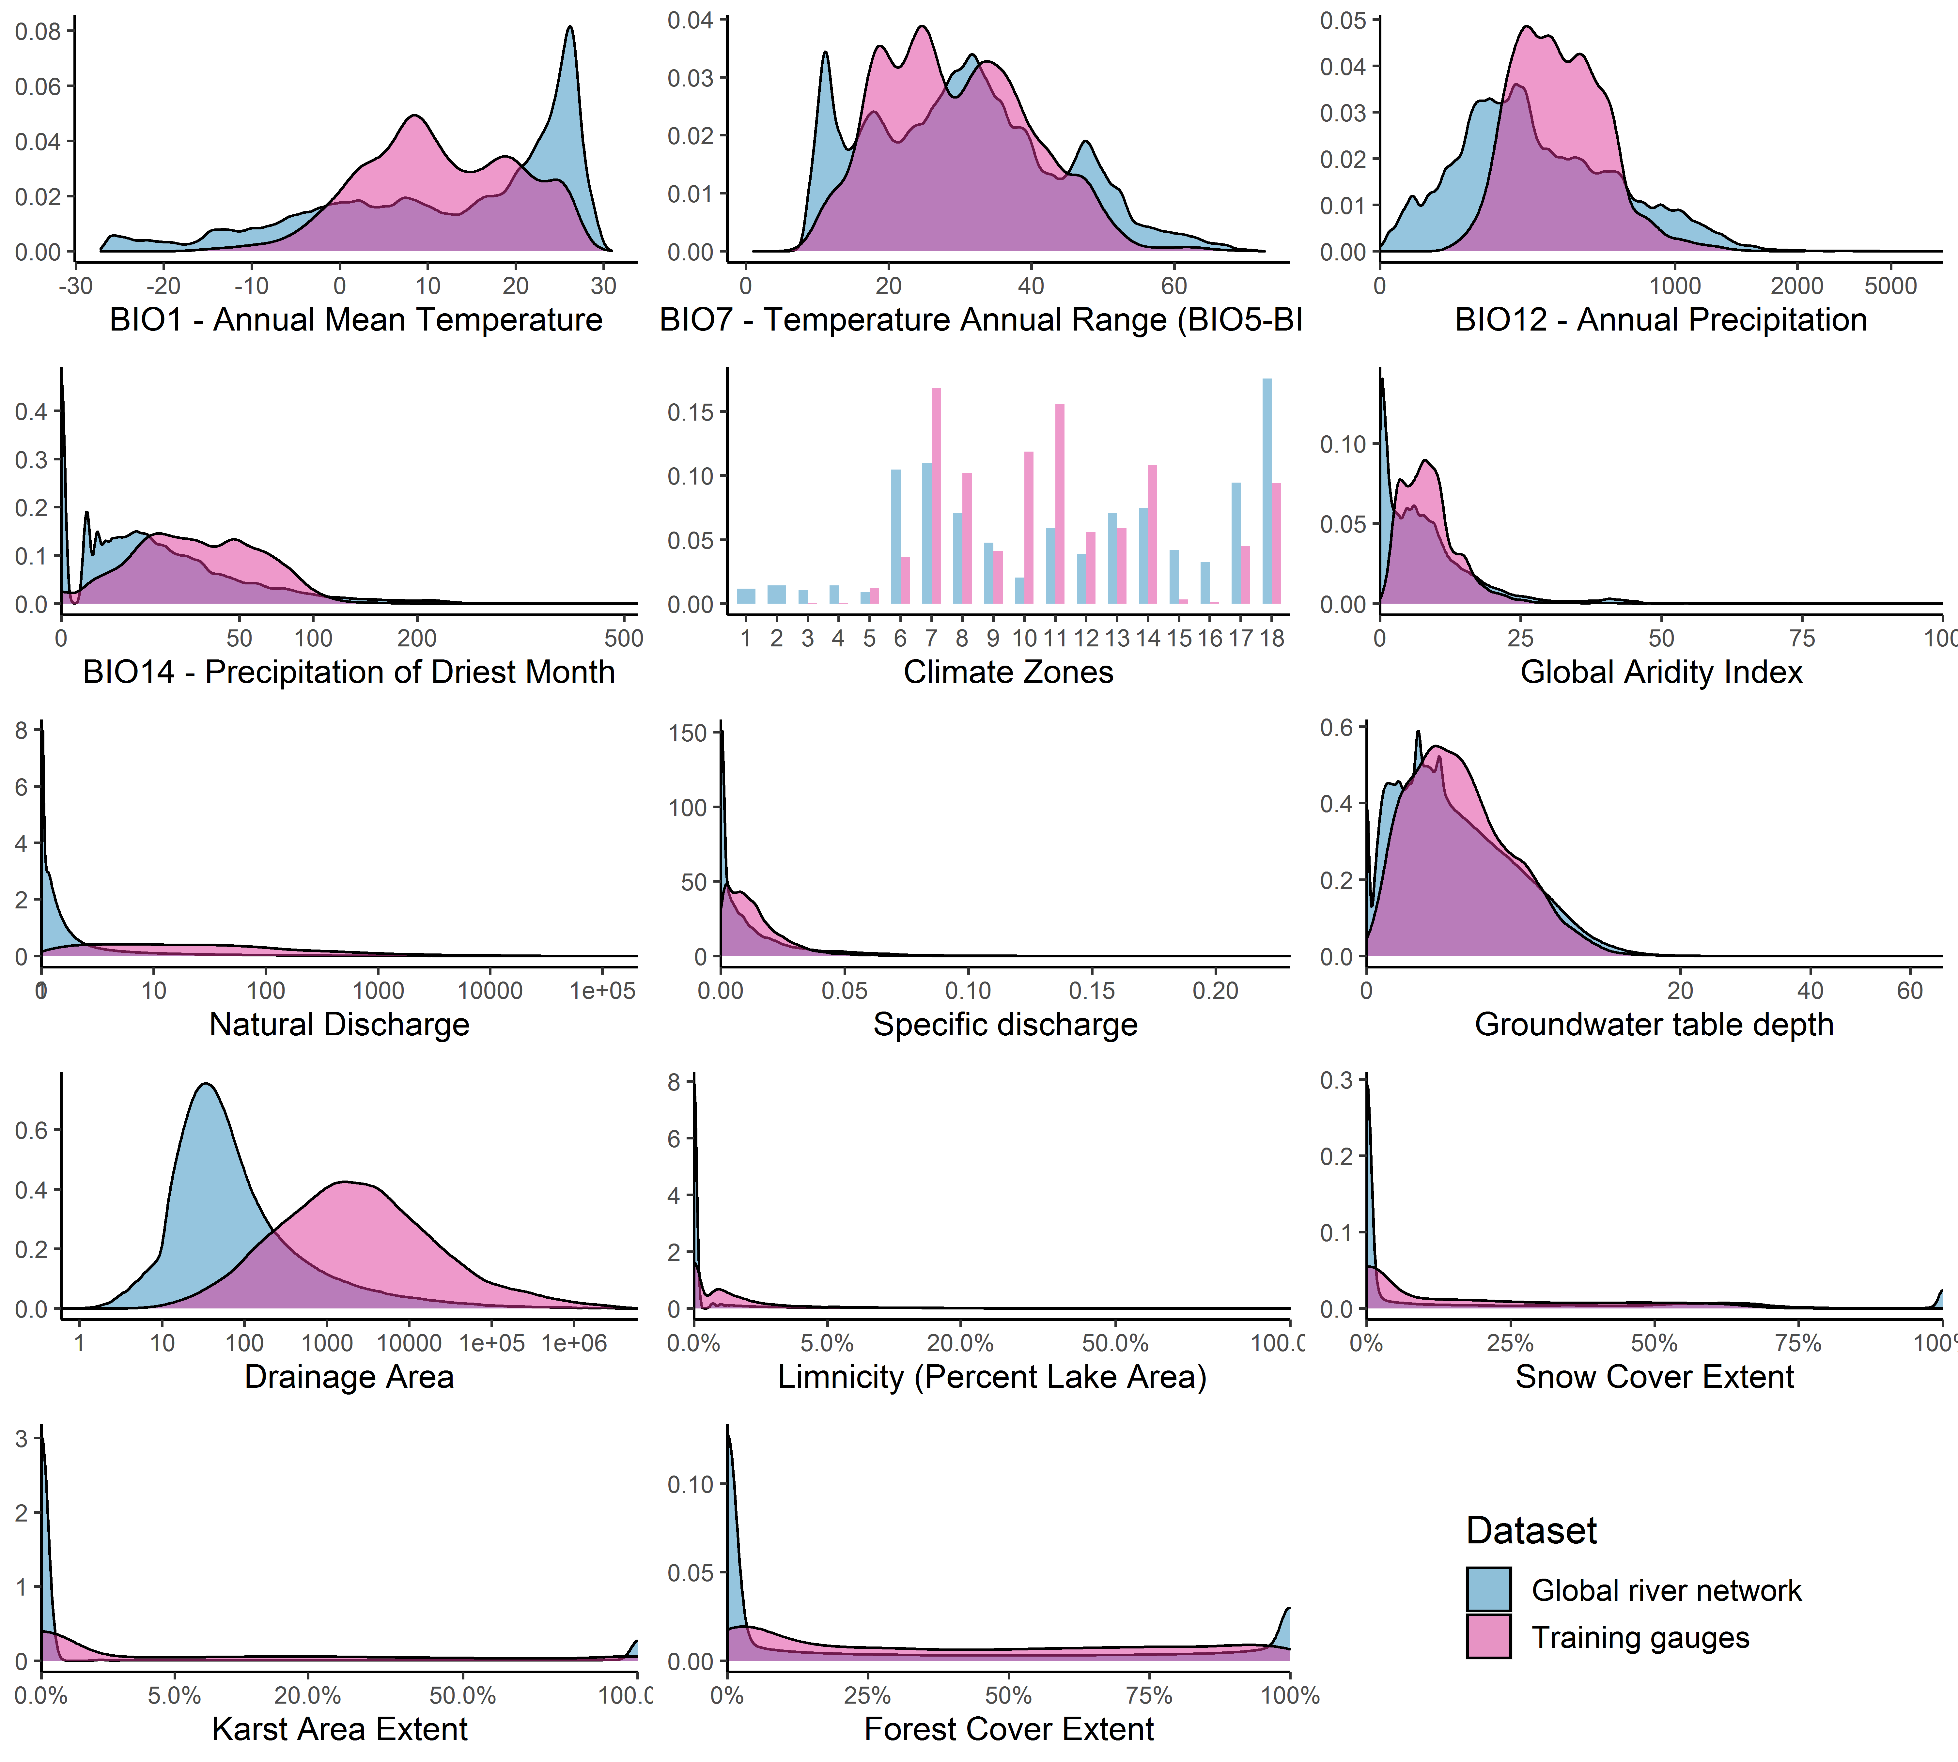

#Methods - Table 2. Specification and benchmark comparison of models

## [1] "Setup table u10"

| selection | type | learner_format | inner_folds | inner_n_evals | alpha | mtry | minnodesize | fraction | minor_weight|ratio | npredictors | outer_repeats | outer_folds |
| --- | --- | --- | --- | --- | --- | --- | --- | --- | --- | --- | --- | --- |
| Algorithm | Classif. | default RF | 4 | 100 |  | 11-56 | 1-10 | 0.2-0.8 | NA | 113 | 2 | 3 |
| Algorithm | Classif. | CIF | NA | NA | 0.05 | 11 |  | 0.632 | NA | 113 | 2 | 3 |
| Algorithm | Classif. | default RF-oversampled | 4 | 100 |  | 11-56 | 1-10 | 0.2-0.8 | 1.044818 | 113 | 2 | 3 |
| Algorithm | Classif. | CIF-oversampled | NA | NA | 0.05 | 11 |  | 0.632 | 1.044818 | 113 | 2 | 3 |
| Algorithm | Classif. | default RF-weighted classes | 4 | 100 |  | 11-56 | 1-10 | 0.2-0.8 | 1.044818 | 113 | 2 | 3 |
| Algorithm | Classif. | CIF-weighted classes | NA | NA | 0.05 | 11 |  | 0.632 | 1.044818 | 113 | 2 | 3 |
| Algorithm | Regr. |  | 4 | 100 |  | 11-56 | 10 |  | NA | 113 | 2 | 3 |
| Predictors | Classif. |  | 4 | 100 |  | 7-37 | 1-10 |  | 1.044818 | 113 | 2 | 3 |

## [1] "Results table u10"

| selection | learner_format | resampling_id | outer_repeats | outer_folds | time_train | time_predict | bacc | threshold_class | spe | sen | bbrier | auc |
| --- | --- | --- | --- | --- | --- | --- | --- | --- | --- | --- | --- | --- |
| Algorithm | default RF | repeated_cv | 2 | 3 | 0 | 0 | 0.873 | 0.5 | 0.885 | 0.862 | 0.095 | 0.873 |
| Algorithm | CIF | repeated_cv | 2 | 3 | 0 | 0 | 0.863 | 0.5 | 0.882 | 0.845 | 0.098 | 0.863 |
| Algorithm | default RF-oversampled | repeated_cv | 2 | 3 | 0 | 0 | 0.871 | 0.5 | 0.884 | 0.859 | 0.095 | 0.871 |
| Algorithm | CIF-oversampled | repeated_cv | 2 | 3 | 0 | 0 | 0.867 | 0.5 | 0.881 | 0.852 | 0.098 | 0.867 |
| Algorithm | default RF-weighted classes | repeated_cv | 2 | 3 | 0 | 0 | 0.870 | 0.5 | 0.877 | 0.864 | 0.095 | 0.870 |
| Algorithm | CIF-weighted classes | repeated_cv | 2 | 3 | 0 | 0 | 0.864 | 0.5 | 0.881 | 0.846 | 0.098 | 0.864 |
| Algorithm |  | repeated_cv | 2 | 3 | 0 | 0 | 0.854 | 0.5 | 0.868 | 0.840 | 0.105 | 0.933 |
| Algorithm |  | repeated_cv | 2 | 3 | 0 | 0 | 0.856 | 0.5 | 0.870 | 0.843 | 0.105 | 0.933 |
| Predictors |  | repeated_cv | 2 | 3 | 0 | 0 | 0.878 | 0.5 | 0.887 | 0.869 | 0.094 | 0.878 |
| Predictors |  | repeated_cv | 1 | 40 | 0 | 0 | 0.877 | 0.5 | 0.889 | 0.865 | 0.093 | 0.877 |
| Predictors |  | repeated-spcv-coords | 2 | 3 | 0 | 0 | 0.840 | 0.5 | 0.826 | 0.853 | 0.125 | 0.840 |

## [1] "Setup table o1"

| selection | type | learner_format | inner_folds | inner_n_evals | alpha | mtry | minnodesize | fraction | minor_weight|ratio | npredictors | outer_repeats | outer_folds |
| --- | --- | --- | --- | --- | --- | --- | --- | --- | --- | --- | --- | --- |
| Algorithm | Classif. | default RF | 4 | 100 |  | 11-56 | 1-10 | 0.2-0.8 | NA | 113 | 2 | 3 |
| Algorithm | Classif. | CIF | NA | NA | 0.05 | 11 |  | 0.632 | NA | 113 | 2 | 3 |
| Algorithm | Classif. | default RF-oversampled | 4 | 100 |  | 11-56 | 1-10 | 0.2-0.8 | 3.954592 | 113 | 2 | 3 |
| Algorithm | Classif. | CIF-oversampled | NA | NA | 0.05 | 11 |  | 0.632 | 3.954592 | 113 | 2 | 3 |
| Algorithm | Classif. | default RF-weighted classes | 4 | 100 |  | 11-56 | 1-10 | 0.2-0.8 | 3.954592 | 113 | 2 | 3 |
| Algorithm | Classif. | CIF-weighted classes | NA | NA | 0.05 | 11 |  | 0.632 | 3.954592 | 113 | 2 | 3 |
| Algorithm | Regr. |  | 4 | 100 |  | 11-56 | 10 |  | NA | 113 | 2 | 3 |
| Predictors | Classif. |  | 4 | 100 |  | 8-41 | 1-10 |  | 3.954592 | 113 | 2 | 3 |

## [1] "Results table o1"

| selection | learner_format | resampling_id | outer_repeats | outer_folds | time_train | time_predict | bacc | threshold_class | spe | sen | bbrier | auc |
| --- | --- | --- | --- | --- | --- | --- | --- | --- | --- | --- | --- | --- |
| Algorithm | default RF | repeated_cv | 2 | 3 | 0 | 0 | 0.870 | 0.5 | 0.973 | 0.767 | 0.056 | 0.870 |
| Algorithm | CIF | repeated_cv | 2 | 3 | 0 | 0 | 0.840 | 0.5 | 0.979 | 0.702 | 0.063 | 0.840 |
| Algorithm | default RF-oversampled | repeated_cv | 2 | 3 | 0 | 0 | 0.895 | 0.5 | 0.922 | 0.868 | 0.067 | 0.895 |
| Algorithm | CIF-oversampled | repeated_cv | 2 | 3 | 0 | 0 | 0.885 | 0.5 | 0.939 | 0.831 | 0.064 | 0.885 |
| Algorithm | default RF-weighted classes | repeated_cv | 2 | 3 | 0 | 0 | 0.894 | 0.5 | 0.921 | 0.866 | 0.068 | 0.894 |
| Algorithm | CIF-weighted classes | repeated_cv | 2 | 3 | 0 | 0 | 0.874 | 0.5 | 0.959 | 0.790 | 0.063 | 0.874 |
| Algorithm |  | repeated_cv | 2 | 3 | 0 | 0 | 0.838 | 0.5 | 0.977 | 0.699 | 0.062 | 0.959 |
| Algorithm |  | repeated_cv | 2 | 3 | 0 | 0 | 0.839 | 0.5 | 0.977 | 0.701 | 0.062 | 0.959 |
| Predictors |  | repeated_cv | 2 | 3 | 0 | 0 | 0.896 | 0.5 | 0.924 | 0.868 | 0.066 | 0.896 |
| Predictors |  | repeated_cv | 1 | 40 | 0 | 0 | 0.898 | 0.5 | 0.918 | 0.879 | 0.068 | 0.898 |
| Predictors |  | repeated-spcv-coords | 2 | 3 | 0 | 0 | 0.840 | 0.5 | 0.918 | 0.763 | 0.088 | 0.840 |

#Methods - Figure 2. Benchmark comparison of models through curves

#Main text - Figure 2. Variable importance for top 20 variables

## Coordinate system already present. Adding new coordinate system, which will replace the existing one.

## Scale for 'x' is already present. Adding another scale for 'x', which will  
## replace the existing scale.

## Scale for 'y' is already present. Adding another scale for 'y', which will  
## replace the existing scale.



#Main text - Figure 3. Partial dependence plots 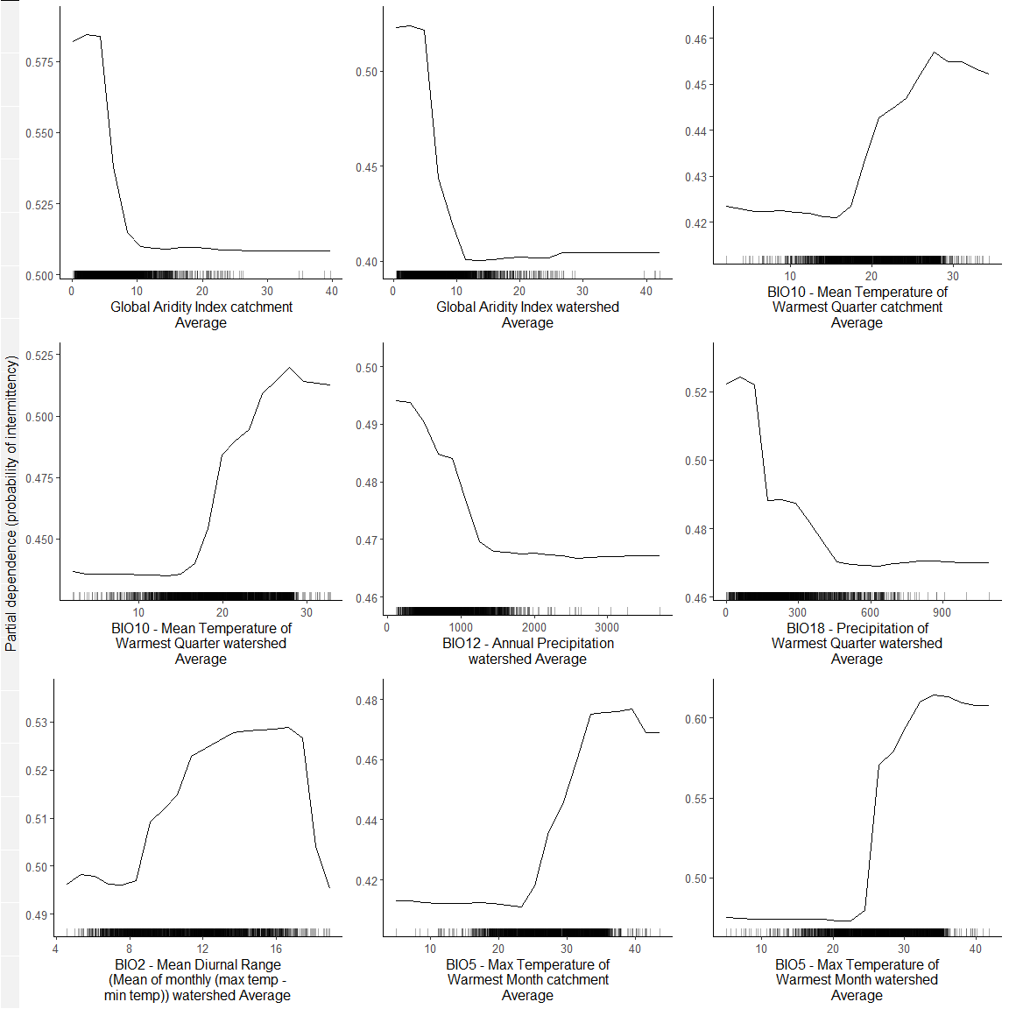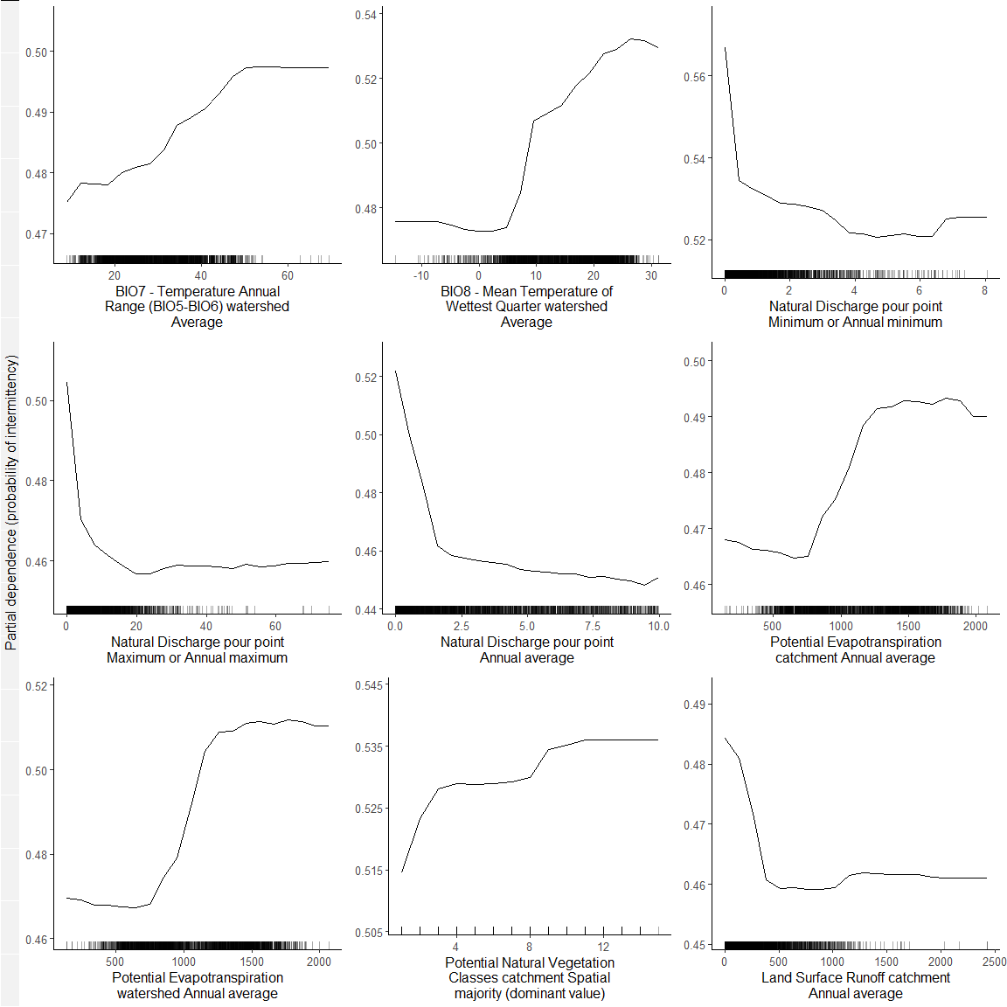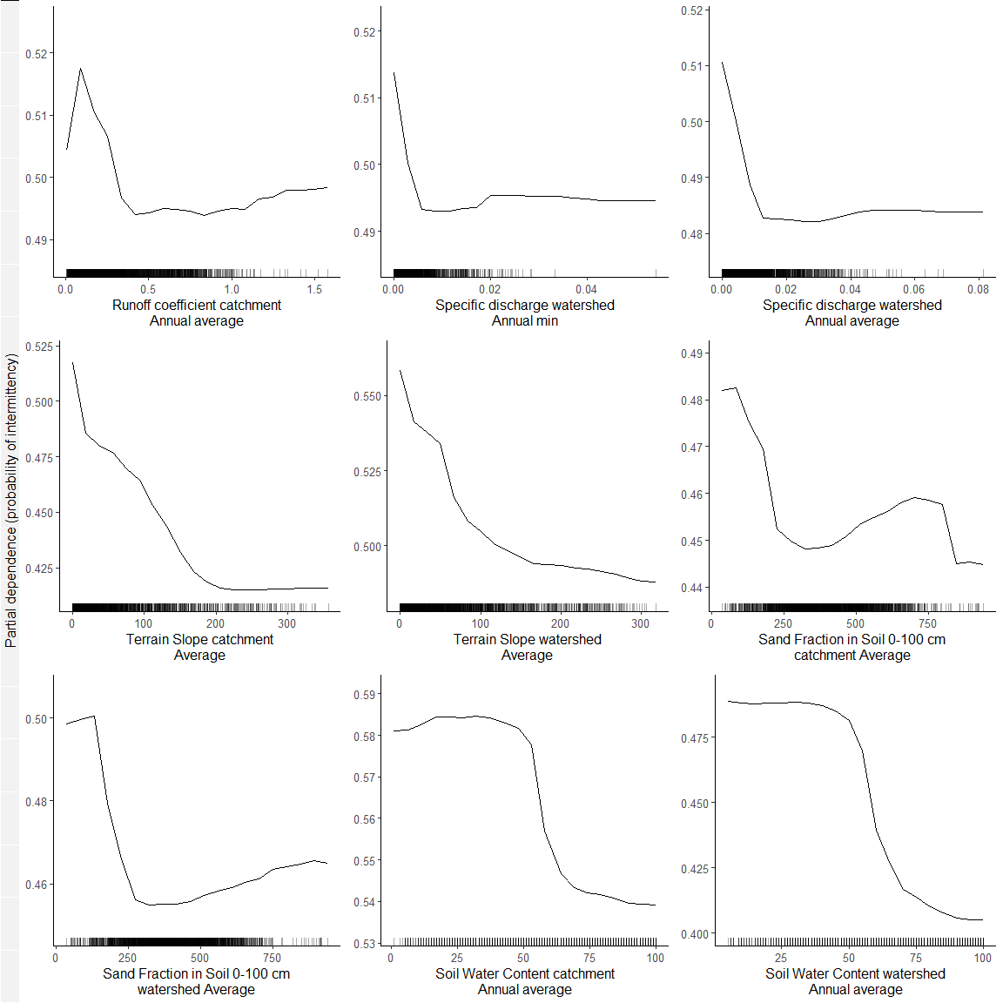

## [[1]]  
## NULL  
##   
## [[2]]  
## NULL  
##   
## [[3]]  
## NULL

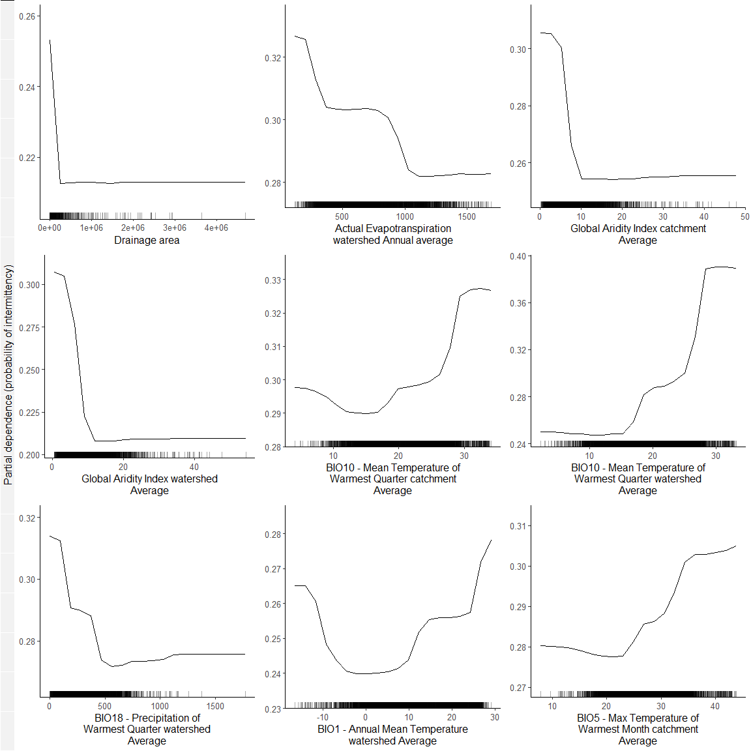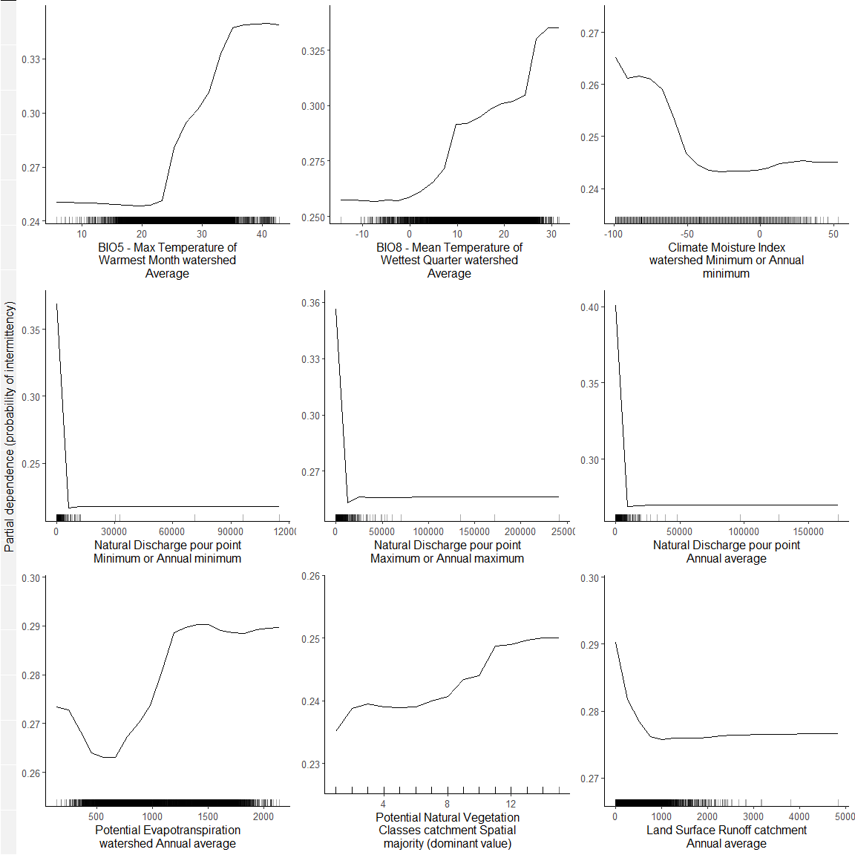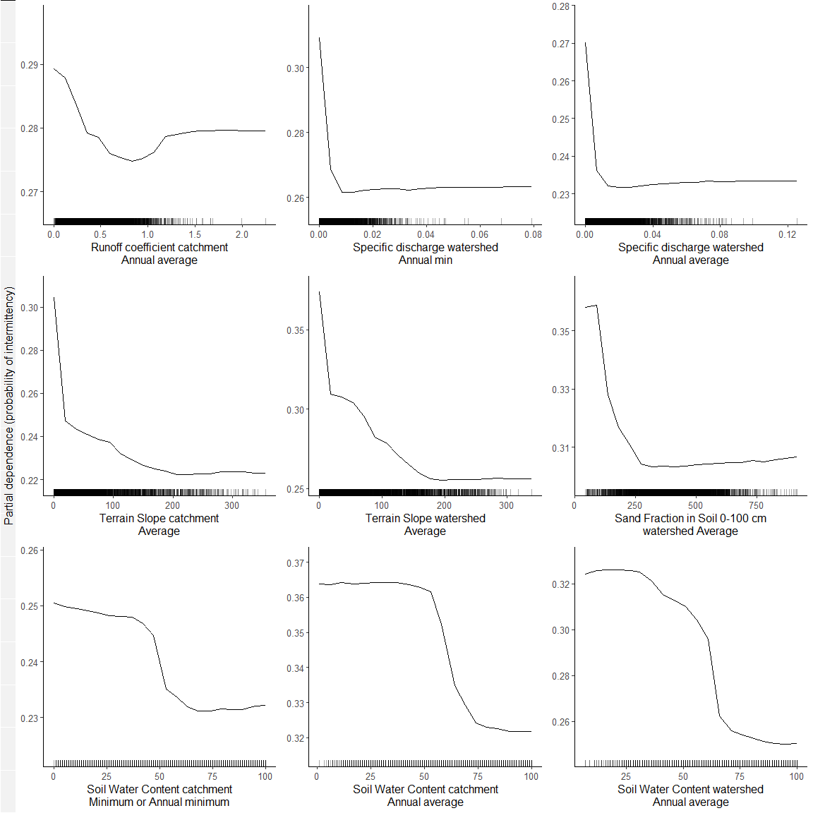

## [[1]]  
## NULL  
##   
## [[2]]  
## NULL  
##   
## [[3]]  
## NULL

#Methods - Figure 3 A. Predictions uncertainty by metavariable and environment 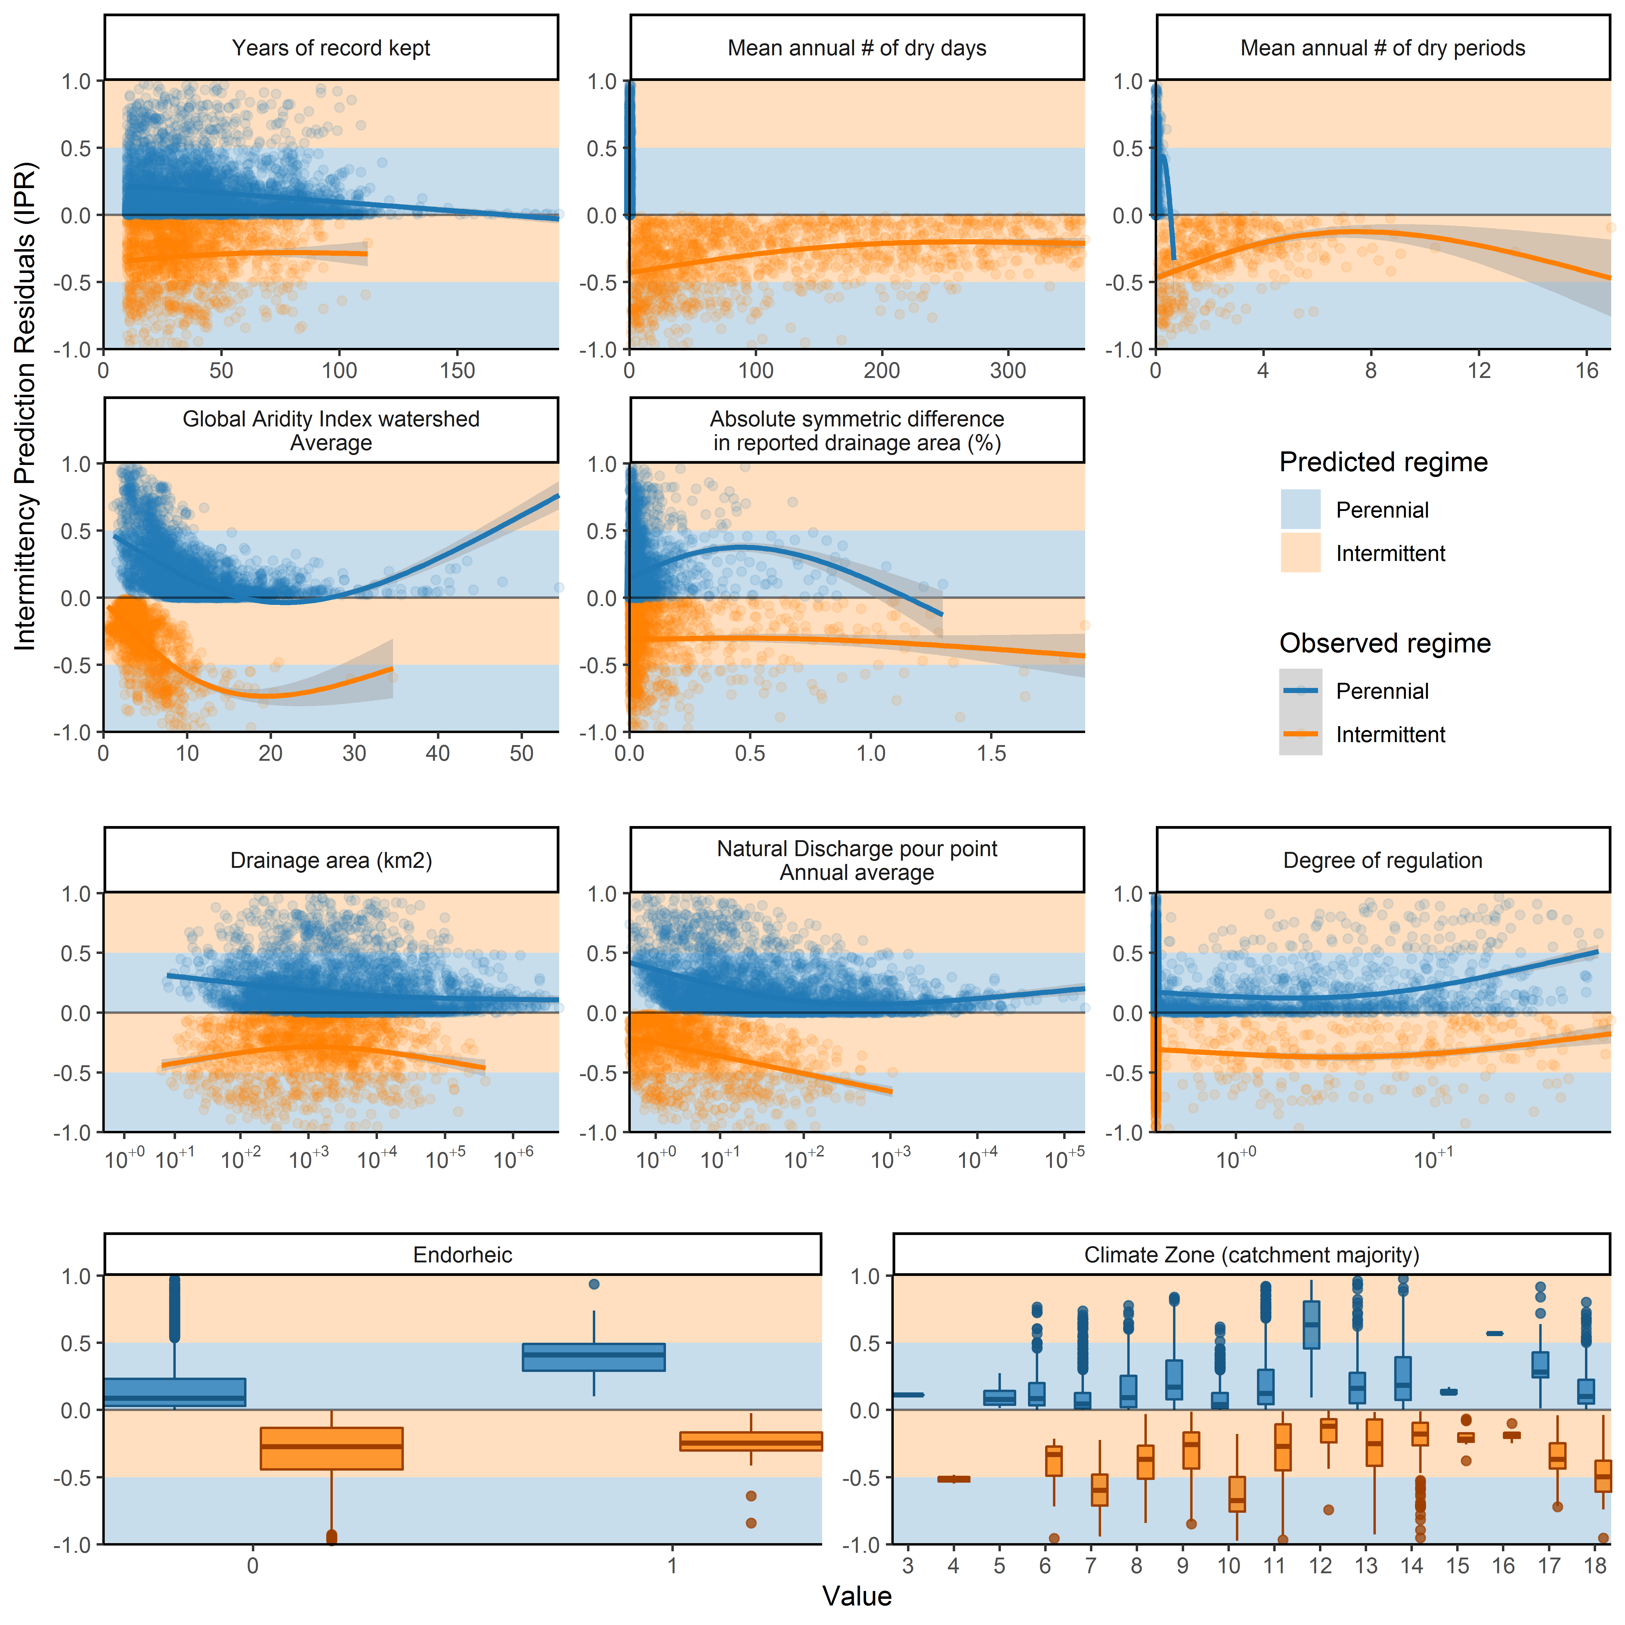

#Final binned summary statistics

| bin | paste0 | inter_confu | pere_confu | misclas | sens | spec | N | predtrue_inter |
| --- | --- | --- | --- | --- | --- | --- | --- | --- |
| 1 | 0-0.1 | 47|0 | 4|0 | 0.078 | 1.00 | 0.00 | 51 | 100|92 |
| 2 | 0.1-1 | 326|46 | 39|92 | 0.169 | 0.88 | 0.70 | 503 | 73|74 |
| 3 | 1-9.96 | 550|102 | 177|807 | 0.171 | 0.84 | 0.82 | 1636 | 44|40 |
| 4 | 10.01-99.86 | 171|100 | 97|1568 | 0.102 | 0.63 | 0.94 | 1936 | 14|14 |
| 5 | 100.05-993.26 | 17|28 | 14|887 | 0.044 | 0.38 | 0.98 | 946 | 3|5 |
| 6 | 1004.09-9514.03 | 1|0 | 0|248 | 0.000 | 1.00 | 1.00 | 249 | 0|0 |
| 7 | 10060.39-173274.11 | 0|0 | 0|34 | 0.000 | NaN | 1.00 | 34 | 0|0 |
| NA | All | 1112|276 | 331|3636 | 0.113 | 0.80 | 0.92 | 5355 | 27|26 |

#Tables of intermittence by categories

| clz_cl_cmj | 0.1-0.999 | 1-9.9989996 | 10-99.9980011 | 100.0009995-999.9379883 | 1000.0050049-9999.84375 | 10001.3261719-205603.6875 | Total intermittency (%) | Total stream length (10^3 km) |
| --- | --- | --- | --- | --- | --- | --- | --- | --- |
| World | 56 | 36 | 26 | 8 | 1 | 0 | 46 | 23291 |
| Extremely hot and moist | 19 | 19 | 20 | 2 | 0 | 0 | 18 | 6002 |
| Cold and mesic | 73 | 29 | 7 | 2 | 0 | 0 | 55 | 3084 |
| Extremely cold and mesic | 79 | 48 | 37 | 30 | 29 | 0 | 68 | 3050 |
| Hot and mesic | 31 | 25 | 23 | 4 | 0 | 0 | 28 | 2022 |
| Hot and dry | 55 | 42 | 22 | 5 | 0 | 0 | 47 | 1682 |
| Warm temperate and mesic | 55 | 39 | 12 | 0 | 0 | 0 | 46 | 1645 |
| Extremely hot and xeric | 88 | 88 | 88 | 34 | 0 | 0 | 85 | 1605 |
| Cool temperate and dry | 73 | 38 | 11 | 0 | 0 | 0 | 58 | 1324 |
| Cool temperate and moist | 35 | 16 | 0 | 0 | 0 | NA | 26 | 691 |
| Cool temperate and xeric | 88 | 63 | 27 | 2 | 0 | NA | 74 | 551 |
| Warm temperate and xeric | 97 | 87 | 49 | 12 | 0 | 0 | 88 | 443 |
| Cold and wet | 1 | 0 | 0 | 0 | 0 | NA | 0 | 299 |
| Extremely hot and arid | 100 | 100 | 97 | 42 | 0 | NA | 97 | 249 |
| Extremely cold and wet 2 | 93 | 72 | 42 | 42 | NA | NA | 88 | 243 |
| Hot and arid | 100 | 99 | 97 | 54 | 0 | NA | 97 | 237 |
| Extremely cold and wet 1 | 32 | 5 | 0 | 0 | NA | NA | 28 | 109 |
| Arctic 2 | 24 | 0 | 0 | NA | NA | NA | 21 | 40 |
| Arctic 1 | 26 | 0 | 0 | NA | NA | NA | 25 | 6 |

| tbi_cl_cmj | 0.1-0.999 | 1-9.9989996 | 10-99.9980011 | 100.0009995-999.9379883 | 1000.0050049-9999.84375 | 10001.3261719-205603.6875 | Total intermittency (%) | Total stream length (10^3 km) |
| --- | --- | --- | --- | --- | --- | --- | --- | --- |
| World | 56 | 36 | 26 | 8 | 1 | 0 | 46 | 23291 |
| Tropical & Subtropical Moist Broadleaf Forests | 10 | 11 | 13 | 2 | 0 | 0 | 10 | 6397 |
| Tropical & Subtropical Grasslands, Savannas & Shrublands | 58 | 54 | 51 | 15 | 0 | 0 | 55 | 3408 |
| Boreal Forests/Taiga | 79 | 35 | 15 | 10 | 1 | 0 | 61 | 3091 |
| Temperate Broadleaf & Mixed Forests | 56 | 27 | 6 | 0 | 0 | 0 | 43 | 2815 |
| Tundra | 86 | 63 | 48 | 32 | 41 | 0 | 77 | 1680 |
| Deserts & Xeric Shrublands | 95 | 87 | 61 | 35 | 0 | NA | 90 | 1312 |
| Temperate Grasslands, Savannas & Shrublands | 93 | 77 | 31 | 3 | 0 | 0 | 81 | 1231 |
| Tropical & Subtropical Dry Broadleaf Forests | 62 | 62 | 60 | 17 | 0 | 0 | 60 | 840 |
| Temperate Conifer Forests | 46 | 15 | 3 | 0 | 0 | NA | 34 | 812 |
| Montane Grasslands & Shrublands | 66 | 28 | 7 | 0 | 0 | NA | 54 | 630 |
| Mediterranean Forests, Woodlands & Scrub | 86 | 66 | 41 | 13 | 0 | NA | 77 | 429 |
| N/A | 52 | 20 | 18 | 0 | NA | NA | 47 | 249 |
| Flooded Grasslands & Savannas | 74 | 69 | 46 | 12 | 0 | 0 | 63 | 178 |
| Tropical & Subtropical Coniferous Forests | 31 | 14 | 8 | 0 | 0 | NA | 25 | 128 |
| Mangroves | 40 | 52 | 36 | 5 | 0 | 0 | 42 | 84 |

| fmh_cl_cmj | 0.1-0.999 | 1-9.9989996 | 10-99.9980011 | 100.0009995-999.9379883 | 1000.0050049-9999.84375 | 10001.3261719-205603.6875 | Total intermittency (%) | Total stream length (10^3 km) |
| --- | --- | --- | --- | --- | --- | --- | --- | --- |
| World | 56 | 36 | 26 | 8 | 1 | 0 | 46 | 23291 |
| Tropical and subtropical floodplain rivers and wetlands | 38 | 36 | 39 | 10 | 0 | 0 | 36 | 3821 |
| Polar freshwaters | 87 | 56 | 33 | 17 | 8 | 0 | 74 | 3665 |
| Tropical and subtropical coastal rivers | 30 | 27 | 29 | 9 | 0 | NA | 29 | 3000 |
| Temperate coastal rivers | 54 | 22 | 8 | 2 | 0 | 0 | 41 | 2897 |
| Tropical and subtropical upland rivers | 17 | 12 | 13 | 1 | 0 | 0 | 15 | 2485 |
| Temperate floodplain rivers and wetlands | 70 | 43 | 17 | 5 | 0 | 0 | 57 | 2448 |
| Xeric freshwaters and endorheic basins | 92 | 82 | 64 | 33 | 0 | NA | 87 | 1833 |
| Temperate upland rivers | 75 | 52 | 17 | 1 | 0 | 0 | 62 | 1102 |
| Montane freshwaters | 22 | 8 | 4 | 0 | 0 | 0 | 15 | 975 |
| Large lakes | 73 | 42 | 16 | 0 | 0 | NA | 60 | 488 |
| Greenland | 56 | 34 | 28 | 7 | NA | NA | 52 | 281 |
| Large river deltas | 14 | 32 | 35 | 1 | 0 | 0 | 20 | 276 |
| Oceanic islands | 12 | 12 | 3 | 0 | NA | NA | 12 | 12 |
| No Data | 72 | 78 | NA | NA | NA | NA | 73 | 1 |

| gad_id_cmj | 0.1-0.999 | 1-9.9989996 | 10-99.9980011 | 100.0009995-999.9379883 | 1000.0050049-9999.84375 | 10001.3261719-205603.6875 | Total intermittency (%) | Total stream length (10^3 km) |
| --- | --- | --- | --- | --- | --- | --- | --- | --- |
| World | 56 | 36 | 26 | 8 | 1 | 0 | 46 | 23291 |
| Russia | 85 | 49 | 26 | 15 | 8 | 0 | 70 | 3358 |
| Brazil | 12 | 10 | 8 | 0 | 0 | 0 | 11 | 2377 |
| Canada | 73 | 34 | 14 | 2 | 0 | 0 | 57 | 1781 |
| United States | 82 | 56 | 19 | 2 | 0 | 0 | 68 | 1728 |
| China | 64 | 38 | 11 | 0 | 0 | 0 | 51 | 1410 |
| India | 77 | 76 | 75 | 36 | 0 | 0 | 74 | 765 |
| Indonesia | 4 | 2 | 1 | 0 | 0 | NA | 3 | 700 |
| Australia | 91 | 89 | 84 | 72 | 0 | NA | 90 | 674 |
| Democratic Republic of the Congo | 5 | 5 | 4 | 0 | 0 | 0 | 5 | 557 |
| Colombia | 3 | 10 | 18 | 1 | 0 | 0 | 7 | 466 |
| Peru | 14 | 3 | 0 | 0 | 0 | 0 | 9 | 422 |
| Argentina | 92 | 74 | 32 | 1 | 0 | 0 | 80 | 322 |
| Venezuela | 14 | 22 | 28 | 5 | 0 | 0 | 17 | 283 |
| Greenland | 56 | 34 | 28 | 7 | NA | NA | 52 | 281 |
| Mexico | 60 | 47 | 46 | 12 | 0 | NA | 55 | 265 |
| Myanmar | 21 | 31 | 39 | 7 | 0 | 0 | 25 | 248 |
| Angola | 39 | 33 | 24 | 1 | 0 | 0 | 35 | 226 |
| Bolivia | 27 | 18 | 23 | 0 | 0 | 0 | 23 | 208 |
| Nigeria | 60 | 65 | 81 | 22 | 0 | NA | 62 | 202 |
| Iran | 89 | 75 | 56 | 13 | 0 | NA | 83 | 201 |
| Papua New Guinea | 2 | 4 | 1 | 0 | 0 | NA | 3 | 188 |
| Ethiopia | 59 | 49 | 42 | 6 | 0 | NA | 54 | 187 |
| Tanzania | 67 | 69 | 54 | 4 | 0 | NA | 65 | 172 |
| Madagascar | 37 | 30 | 23 | 7 | 0 | NA | 33 | 170 |
| Mozambique | 76 | 76 | 71 | 33 | 0 | NA | 74 | 162 |
| Turkey | 71 | 34 | 10 | 0 | NA | NA | 57 | 148 |
| Kazakhstan | 97 | 81 | 36 | 0 | 0 | NA | 85 | 148 |
| France | 33 | 15 | 0 | 0 | 0 | NA | 24 | 138 |
| Zambia | 70 | 73 | 54 | 2 | 0 | NA | 67 | 134 |
| Chile | 28 | 11 | 4 | 0 | NA | NA | 21 | 133 |
| Thailand | 21 | 44 | 55 | 0 | 0 | NA | 29 | 132 |
| Malaysia | 2 | 0 | 0 | 0 | 0 | NA | 1 | 127 |
| Central African Republic | 24 | 25 | 28 | 1 | 0 | NA | 24 | 126 |
| Cameroon | 15 | 12 | 11 | 1 | 0 | NA | 13 | 125 |
| Japan | 6 | 0 | 0 | 0 | NA | NA | 4 | 123 |
| Vietnam | 11 | 24 | 31 | 0 | 0 | 0 | 16 | 108 |
| Philippines | 0 | 15 | 18 | 0 | 0 | NA | 7 | 106 |
| South Africa | 82 | 80 | 77 | 74 | NA | NA | 81 | 105 |
| Pakistan | 95 | 74 | 64 | 14 | 0 | NA | 83 | 101 |
| Sudan | 100 | 100 | 100 | 73 | 0 | NA | 96 | 100 |
| Ukraine | 50 | 0 | 0 | 0 | 0 | NA | 35 | 94 |
| Algeria | 99 | 99 | 98 | NA | NA | NA | 99 | 94 |
| Ecuador | 8 | 4 | 1 | 0 | 0 | NA | 5 | 94 |
| Kenya | 80 | 69 | 70 | 24 | NA | NA | 76 | 90 |
| New Zealand | 2 | 0 | 0 | 0 | NA | NA | 1 | 89 |
| Sweden | 42 | 0 | 0 | 0 | NA | NA | 26 | 88 |
| Spain | 69 | 43 | 25 | 2 | NA | NA | 59 | 88 |
| Republic of Congo | 0 | 0 | 0 | 0 | 0 | 0 | 0 | 88 |
| Chad | 100 | 100 | 99 | 23 | 0 | NA | 97 | 85 |
| Mali | 99 | 100 | 99 | 25 | 0 | NA | 96 | 84 |
| Gabon | 0 | 0 | 2 | 0 | 0 | NA | 0 | 84 |
| Norway | 10 | 0 | 0 | 0 | NA | NA | 6 | 82 |
| Germany | 15 | 0 | 0 | 0 | 0 | NA | 9 | 82 |
| Afghanistan | 53 | 24 | 8 | 0 | 0 | NA | 42 | 79 |
| Italy | 65 | 34 | 3 | 0 | 0 | NA | 50 | 74 |
| South Sudan | 79 | 79 | 80 | 16 | 0 | NA | 75 | 74 |
| Laos | 1 | 15 | 18 | 0 | 0 | NA | 7 | 72 |
| Guyana | 4 | 6 | 4 | 0 | 0 | NA | 5 | 71 |
| Saudi Arabia | 100 | 100 | 100 | 92 | NA | NA | 99 | 71 |
| Cote d'Ivoire | 35 | 38 | 54 | 6 | NA | NA | 36 | 70 |
| Guinea | 27 | 42 | 49 | 24 | NA | NA | 33 | 68 |
| Mongolia | 100 | 96 | 30 | 0 | NA | NA | 91 | 68 |
| United Kingdom | 0 | 0 | 0 | 0 | NA | NA | 0 | 67 |
| Finland | 67 | 0 | 0 | 0 | NA | NA | 44 | 63 |
| Paraguay | 65 | 57 | 37 | 6 | 0 | 0 | 58 | 62 |
| Poland | 22 | 0 | 0 | 0 | 0 | NA | 15 | 62 |
| Cambodia | 4 | 35 | 63 | 4 | 0 | 0 | 19 | 58 |
| Bangladesh | 65 | 91 | 82 | 5 | 0 | 0 | 71 | 55 |
| Zimbabwe | 95 | 93 | 95 | 100 | 0 | NA | 94 | 53 |
| Morocco | 93 | 92 | 90 | 92 | NA | NA | 93 | 52 |
| Romania | 62 | 26 | 3 | 0 | 0 | NA | 48 | 51 |
| Ghana | 39 | 43 | 60 | 11 | 0 | NA | 40 | 49 |
| Niger | 100 | 100 | 100 | 0 | 0 | NA | 98 | 49 |
| Nepal | 32 | 27 | 12 | 0 | 0 | NA | 27 | 49 |
| Uruguay | 90 | 53 | 0 | 0 | 0 | NA | 69 | 47 |
| Suriname | 7 | 7 | 0 | 0 | 0 | NA | 6 | 45 |
| Libya | 100 | 100 | 100 | NA | NA | NA | 100 | 42 |
| Somalia | 100 | 100 | 100 | 77 | NA | NA | 99 | 42 |
| Belarus | 35 | 0 | 0 | 0 | NA | NA | 24 | 42 |
| Uganda | 31 | 40 | 15 | 0 | 0 | NA | 31 | 41 |
| Iceland | 2 | 0 | 0 | 0 | NA | NA | 1 | 41 |
| Nicaragua | 1 | 4 | 10 | 0 | 0 | NA | 3 | 40 |
| Liberia | 0 | 0 | 2 | 0 | NA | NA | 0 | 38 |
| Guatemala | 1 | 5 | 8 | 0 | 0 | NA | 3 | 37 |
| Iraq | 92 | 81 | 76 | 0 | 0 | NA | 81 | 35 |
| Namibia | 100 | 100 | 100 | 46 | 0 | NA | 98 | 35 |
| Kyrgyzstan | 83 | 26 | 0 | 0 | NA | NA | 65 | 34 |
| Mauritania | 100 | 100 | 99 | 24 | NA | NA | 99 | 33 |
| Honduras | 1 | 4 | 4 | 0 | NA | NA | 2 | 32 |
| French Guiana | 0 | 0 | 0 | 0 | 0 | NA | 0 | 32 |
| Sierra Leone | 0 | 17 | 45 | 2 | NA | NA | 8 | 31 |
| North Korea | 47 | 1 | 0 | 0 | NA | NA | 30 | 28 |
| Tajikistan | 88 | 17 | 5 | 0 | 0 | NA | 61 | 27 |
| Botswana | 100 | 100 | 100 | 43 | 0 | NA | 98 | 26 |
| Panama | 0 | 7 | 6 | 0 | NA | NA | 3 | 26 |
| Burkina Faso | 100 | 100 | 100 | 100 | NA | NA | 100 | 26 |
| South Korea | 43 | 3 | 0 | 0 | NA | NA | 28 | 24 |
| Cuba | 11 | 18 | 62 | 0 | NA | NA | 15 | 24 |
| Malawi | 60 | 68 | 60 | 0 | 0 | NA | 60 | 23 |
| Greece | 77 | 42 | 9 | 0 | NA | NA | 65 | 23 |
| Yemen | 100 | 100 | 100 | NA | NA | NA | 100 | 23 |
| Austria | 8 | 0 | 0 | 0 | 0 | NA | 4 | 22 |
| Bulgaria | 64 | 26 | 2 | 0 | 0 | NA | 51 | 22 |
| Costa Rica | 0 | 1 | 5 | 0 | 0 | NA | 1 | 22 |
| Benin | 98 | 99 | 96 | 39 | 0 | NA | 96 | 21 |
| Portugal | 83 | 62 | 31 | 2 | NA | NA | 72 | 20 |
| Ireland | 0 | 0 | 0 | 0 | NA | NA | 0 | 20 |
| Georgia | 23 | 4 | 0 | 0 | NA | NA | 15 | 19 |
| Senegal | 100 | 100 | 100 | 79 | NA | NA | 98 | 18 |
| Uzbekistan | 83 | 44 | 5 | 0 | 0 | NA | 63 | 18 |
| Sri Lanka | 7 | 34 | 49 | 0 | NA | NA | 20 | 17 |
| Czech Republic | 24 | 0 | 0 | 0 | NA | NA | 16 | 16 |
| Hungary | 71 | 34 | 0 | 0 | 0 | NA | 55 | 16 |
| Latvia | 56 | 0 | 0 | 0 | NA | NA | 34 | 15 |
| Serbia | 48 | 25 | 8 | 0 | 0 | NA | 38 | 15 |
| Lithuania | 45 | 0 | 0 | 0 | NA | NA | 29 | 14 |
| Turkmenistan | 98 | 95 | 55 | 0 | 0 | NA | 81 | 14 |
| Eritrea | 100 | 100 | 100 | 0 | NA | NA | 99 | 14 |
| Oman | 100 | 100 | 100 | NA | NA | NA | 100 | 14 |
| Tunisia | 100 | 100 | 65 | NA | NA | NA | 99 | 14 |
| Azerbaijan | 69 | 11 | 0 | 0 | NA | NA | 48 | 13 |
| Croatia | 50 | 11 | 0 | 0 | 0 | NA | 35 | 13 |
| Svalbard and Jan Mayen | 99 | 99 | 99 | NA | NA | NA | 99 | 13 |
| Bosnia and Herzegovina | 24 | 4 | 0 | 0 | 0 | NA | 16 | 13 |
| Taiwan | 10 | 16 | 6 | 0 | NA | NA | 12 | 13 |
| Togo | 58 | 65 | 82 | 13 | NA | NA | 62 | 12 |
| Switzerland | 1 | 0 | 0 | 0 | 0 | NA | 0 | 12 |
| Syria | 96 | 97 | 74 | 0 | NA | NA | 91 | 11 |
| Dominican Republic | 19 | 14 | 4 | 0 | NA | NA | 17 | 11 |
| Slovakia | 21 | 0 | 0 | 0 | 0 | NA | 15 | 10 |
| Equatorial Guinea | 0 | 0 | 0 | 0 | NA | NA | 0 | 10 |
| Bhutan | 26 | 3 | 0 | 0 | NA | NA | 16 | 10 |
| Western Sahara | 100 | 99 | 100 | NA | NA | NA | 100 | 10 |
| Estonia | 61 | 0 | 0 | 0 | NA | NA | 41 | 9 |
| Denmark | 36 | 0 | 0 | NA | NA | NA | 25 | 9 |
| Solomon Islands | 0 | 0 | 0 | NA | NA | NA | 0 | 9 |
| Guinea-Bissau | 100 | 100 | 100 | 25 | NA | NA | 96 | 8 |
| Netherlands | 64 | 2 | 17 | 0 | 0 | NA | 37 | 8 |
| Belgium | 26 | 0 | 0 | 0 | NA | NA | 17 | 7 |
| Albania | 33 | 14 | 0 | 0 | NA | NA | 24 | 7 |
| Belize | 0 | 18 | 4 | 0 | NA | NA | 6 | 6 |
| El Salvador | 0 | 2 | 1 | 0 | NA | NA | 1 | 6 |
| Egypt | 100 | 100 | NA | NA | 0 | NA | 79 | 5 |
| Haiti | 6 | 6 | 0 | 0 | NA | NA | 6 | 5 |
| Burundi | 11 | 11 | 0 | 0 | NA | NA | 10 | 5 |
| Moldova | 77 | 23 | 0 | 0 | NA | NA | 56 | 5 |
| Fiji | 0 | 0 | 0 | 0 | NA | NA | 0 | 5 |
| Slovenia | 5 | 0 | 0 | 0 | NA | NA | 3 | 5 |
| Rwanda | 31 | 23 | 0 | 0 | NA | NA | 26 | 5 |
| Macedonia | 40 | 3 | 0 | 0 | NA | NA | 28 | 5 |
| Lesotho | 31 | 28 | 16 | 0 | NA | NA | 28 | 4 |
| New Caledonia | 0 | 0 | 0 | NA | NA | NA | 0 | 4 |
| Montenegro | 2 | 1 | 0 | 0 | NA | NA | 1 | 4 |
| Armenia | 62 | 7 | 4 | 0 | NA | NA | 48 | 3 |
| Swaziland | 72 | 55 | 6 | NA | NA | NA | 58 | 3 |
| Israel | 97 | 100 | 100 | NA | NA | NA | 98 | 3 |
| East Timor | 0 | 0 | 0 | NA | NA | NA | 0 | 3 |
| Vanuatu | 0 | 0 | 0 | NA | NA | NA | 0 | 2 |
| Kosovo | 31 | 5 | 0 | NA | NA | NA | 22 | 2 |
| Lebanon | 76 | 63 | 80 | NA | NA | NA | 72 | 2 |
| Jamaica | 6 | 7 | 45 | NA | NA | NA | 7 | 2 |
| Jordan | 100 | 100 | 89 | NA | NA | NA | 99 | 2 |
| Brunei | 5 | 0 | 0 | 0 | NA | NA | 3 | 2 |
| Puerto Rico | 3 | 3 | 0 | NA | NA | NA | 3 | 2 |
| Falkland Islands | 2 | 0 | NA | NA | NA | NA | 2 | 1 |
| Cyprus | 87 | 100 | NA | NA | NA | NA | 89 | 1 |
| Gambia | 99 | 100 | 100 | 100 | NA | NA | 100 | 1 |
| Djibouti | 100 | 100 | 100 | NA | NA | NA | 100 | 1 |
| Trinidad and Tobago | 8 | 22 | 0 | NA | NA | NA | 12 | 1 |
| Palestina | 100 | 99 | 100 | NA | NA | NA | 100 | 1 |
| Bahamas | 94 | 70 | NA | NA | NA | NA | 91 | 1 |
| United Arab Emirates | 100 | 100 | NA | NA | NA | NA | 100 | 0 |
| Luxembourg | 2 | 0 | 0 | 0 | NA | NA | 1 | 0 |
| Comoros | 0 | 0 | NA | NA | NA | NA | 0 | 0 |
| Guadeloupe | 2 | 0 | NA | NA | NA | NA | 2 | 0 |
| Martinique | 0 | 0 | NA | NA | NA | NA | 0 | 0 |
| Sao Tome and Principe | 0 | 0 | NA | NA | NA | NA | 0 | 0 |
| Faroe Islands | 0 | 0 | NA | NA | NA | NA | 0 | 0 |
| Kuwait | 100 | NA | NA | NA | NA | NA | 100 | 0 |
| Dominica | 0 | 0 | NA | NA | NA | NA | 0 | 0 |
| Hong Kong | 0 | 0 | 100 | NA | NA | NA | 0 | 0 |
| Saint Lucia | 0 | 0 | NA | NA | NA | NA | 0 | 0 |
| Guam | 0 | 0 | NA | NA | NA | NA | 0 | 0 |
| Singapore | 0 | 0 | NA | NA | NA | NA | 0 | 0 |
| Micronesia | 0 | 0 | NA | NA | NA | NA | 0 | 0 |
| Isle of Man | 0 | 0 | NA | NA | NA | NA | 0 | 0 |
| Andorra | 0 | 0 | NA | NA | NA | NA | 0 | 0 |
| Barbados | 0 | 29 | NA | NA | NA | NA | 4 | 0 |
| Palau | 0 | 0 | NA | NA | NA | NA | 0 | 0 |
| Saint Vincent and the Grenadines | 0 | NA | NA | NA | NA | NA | 0 | 0 |
| Liechtenstein | 0 | 0 | NA | 0 | NA | NA | 0 | 0 |
| Mayotte | 0 | 0 | NA | NA | NA | NA | 0 | 0 |
| Northern Mariana Islands | 0 | NA | NA | NA | NA | NA | 0 | 0 |
| Aland | 100 | NA | NA | NA | NA | NA | 100 | 0 |
| Antigua and Barbuda | 69 | NA | NA | NA | NA | NA | 69 | 0 |
| Grenada | 0 | NA | NA | NA | NA | NA | 0 | 0 |
| Virgin Islands, U.S. | 89 | NA | NA | NA | NA | NA | 89 | 0 |
| Saint Pierre and Miquelon | 0 | NA | NA | NA | NA | NA | 0 | 0 |
| Malta | 100 | NA | NA | NA | NA | NA | 100 | 0 |
| San Marino | 33 | NA | NA | NA | NA | NA | 33 | 0 |
| Cayman Islands | 19 | NA | NA | NA | NA | NA | 19 | 0 |
| Seychelles | 100 | NA | NA | NA | NA | NA | 100 | 0 |
| Jersey | 6 | NA | NA | NA | NA | NA | 6 | 0 |
| Nauru | 0 | NA | NA | NA | NA | NA | 0 | 0 |
| Montserrat | 0 | NA | NA | NA | NA | NA | 0 | 0 |
| Bonaire, Saint Eustatius and Saba | 100 | NA | NA | NA | NA | NA | 100 | 0 |
| Anguilla | 100 | NA | NA | NA | NA | NA | 100 | 0 |
| Guernsey | 0 | NA | NA | NA | NA | NA | 0 | 0 |
| Sint Maarten | 0 | NA | NA | NA | NA | NA | 0 | 0 |
| Kiribati | 100 | NA | NA | NA | NA | NA | 100 | 0 |
| Saint Kitts and Nevis | 0 | NA | NA | NA | NA | NA | 0 | 0 |
| Saint-Martin | 0 | NA | NA | NA | NA | NA | 0 | 0 |

## [1] "Extrapolation"

| clz_cl_cmj | 0.1-0.999 | 1-9.9989996 | 10-99.9980011 | 100.0009995-999.9379883 | 1000.0050049-9999.84375 | 10001.3261719-205603.6875 | 0.01-0.099 | Total intermittence (without extrapolation) - % | Total river length (without extrapolation) - 10^3 km |
| --- | --- | --- | --- | --- | --- | --- | --- | --- | --- |
| World | 56 | 36 | 26 | 8 | 1 | 0 | 65 | 59 (47) | 77250 (23291) |
| Extremely hot and moist | 19 | 19 | 21 | 3 | 0 | 0 | 24 | 23 (19) | 23308 (6002) |
| Extremely cold and mesic | 80 | 49 | 37 | 31 | 30 | 0 | 93 | 86 (69) | 10576 (3051) |
| Cold and mesic | 74 | 29 | 8 | 3 | 0 | 0 | 94 | 82 (55) | 9949 (3084) |
| Hot and mesic | 31 | 25 | 23 | 4 | 0 | 0 | 47 | 41 (28) | 5730 (2023) |
| Hot and dry | 55 | 42 | 23 | 6 | 0 | 0 | 69 | 62 (48) | 5007 (1683) |
| Extremely hot and xeric | 89 | 88 | 88 | 35 | 0 | 0 | 98 | 94 (86) | 4988 (1605) |
| Warm temperate and mesic | 56 | 39 | 12 | 0 | 0 | 0 | 76 | 66 (46) | 4591 (1646) |
| Cool temperate and dry | 73 | 39 | 11 | 0 | 0 | 0 | 90 | 81 (58) | 4384 (1325) |
| Cool temperate and xeric | 88 | 64 | 27 | 2 | 0 | - | 94 | 88 (75) | 1709 (552) |
| Cool temperate and moist | 35 | 17 | 1 | 0 | 0 | - | 54 | 41 (26) | 1516 (691) |
| Warm temperate and xeric | 97 | 87 | 50 | 13 | 0 | 0 | 99 | 96 (89) | 1389 (444) |
| Extremely cold and wet 2 | 94 | 72 | 42 | 43 | - | - | 98 | 96 (88) | 1048 (243) |
| Extremely hot and arid | 100 | 100 | 97 | 42 | 0 | - | 100 | 99 (98) | 981 (249) |
| Hot and arid | 100 | 100 | 97 | 54 | 0 | - | 100 | 99 (98) | 963 (238) |
| Cold and wet | 1 | 0 | 0 | 0 | 0 | - | 4 | 2 (1) | 586 (299) |
| Extremely cold and wet 1 | 33 | 6 | 0 | 0 | - | - | 61 | 51 (28) | 377 (109) |
| Arctic 2 | 24 | 0 | 0 | - | - | - | 47 | 39 (22) | 132 (41) |
| Arctic 1 | 26 | 0 | 0 | - | - | - | 76 | 56 (25) | 16 (6) |

#Comparison of results with regional-national estimates

## Warning in if (!expand) {: the condition has length > 1 and only the first  
## element will be used  
  
## Warning in if (!expand) {: the condition has length > 1 and only the first  
## element will be used

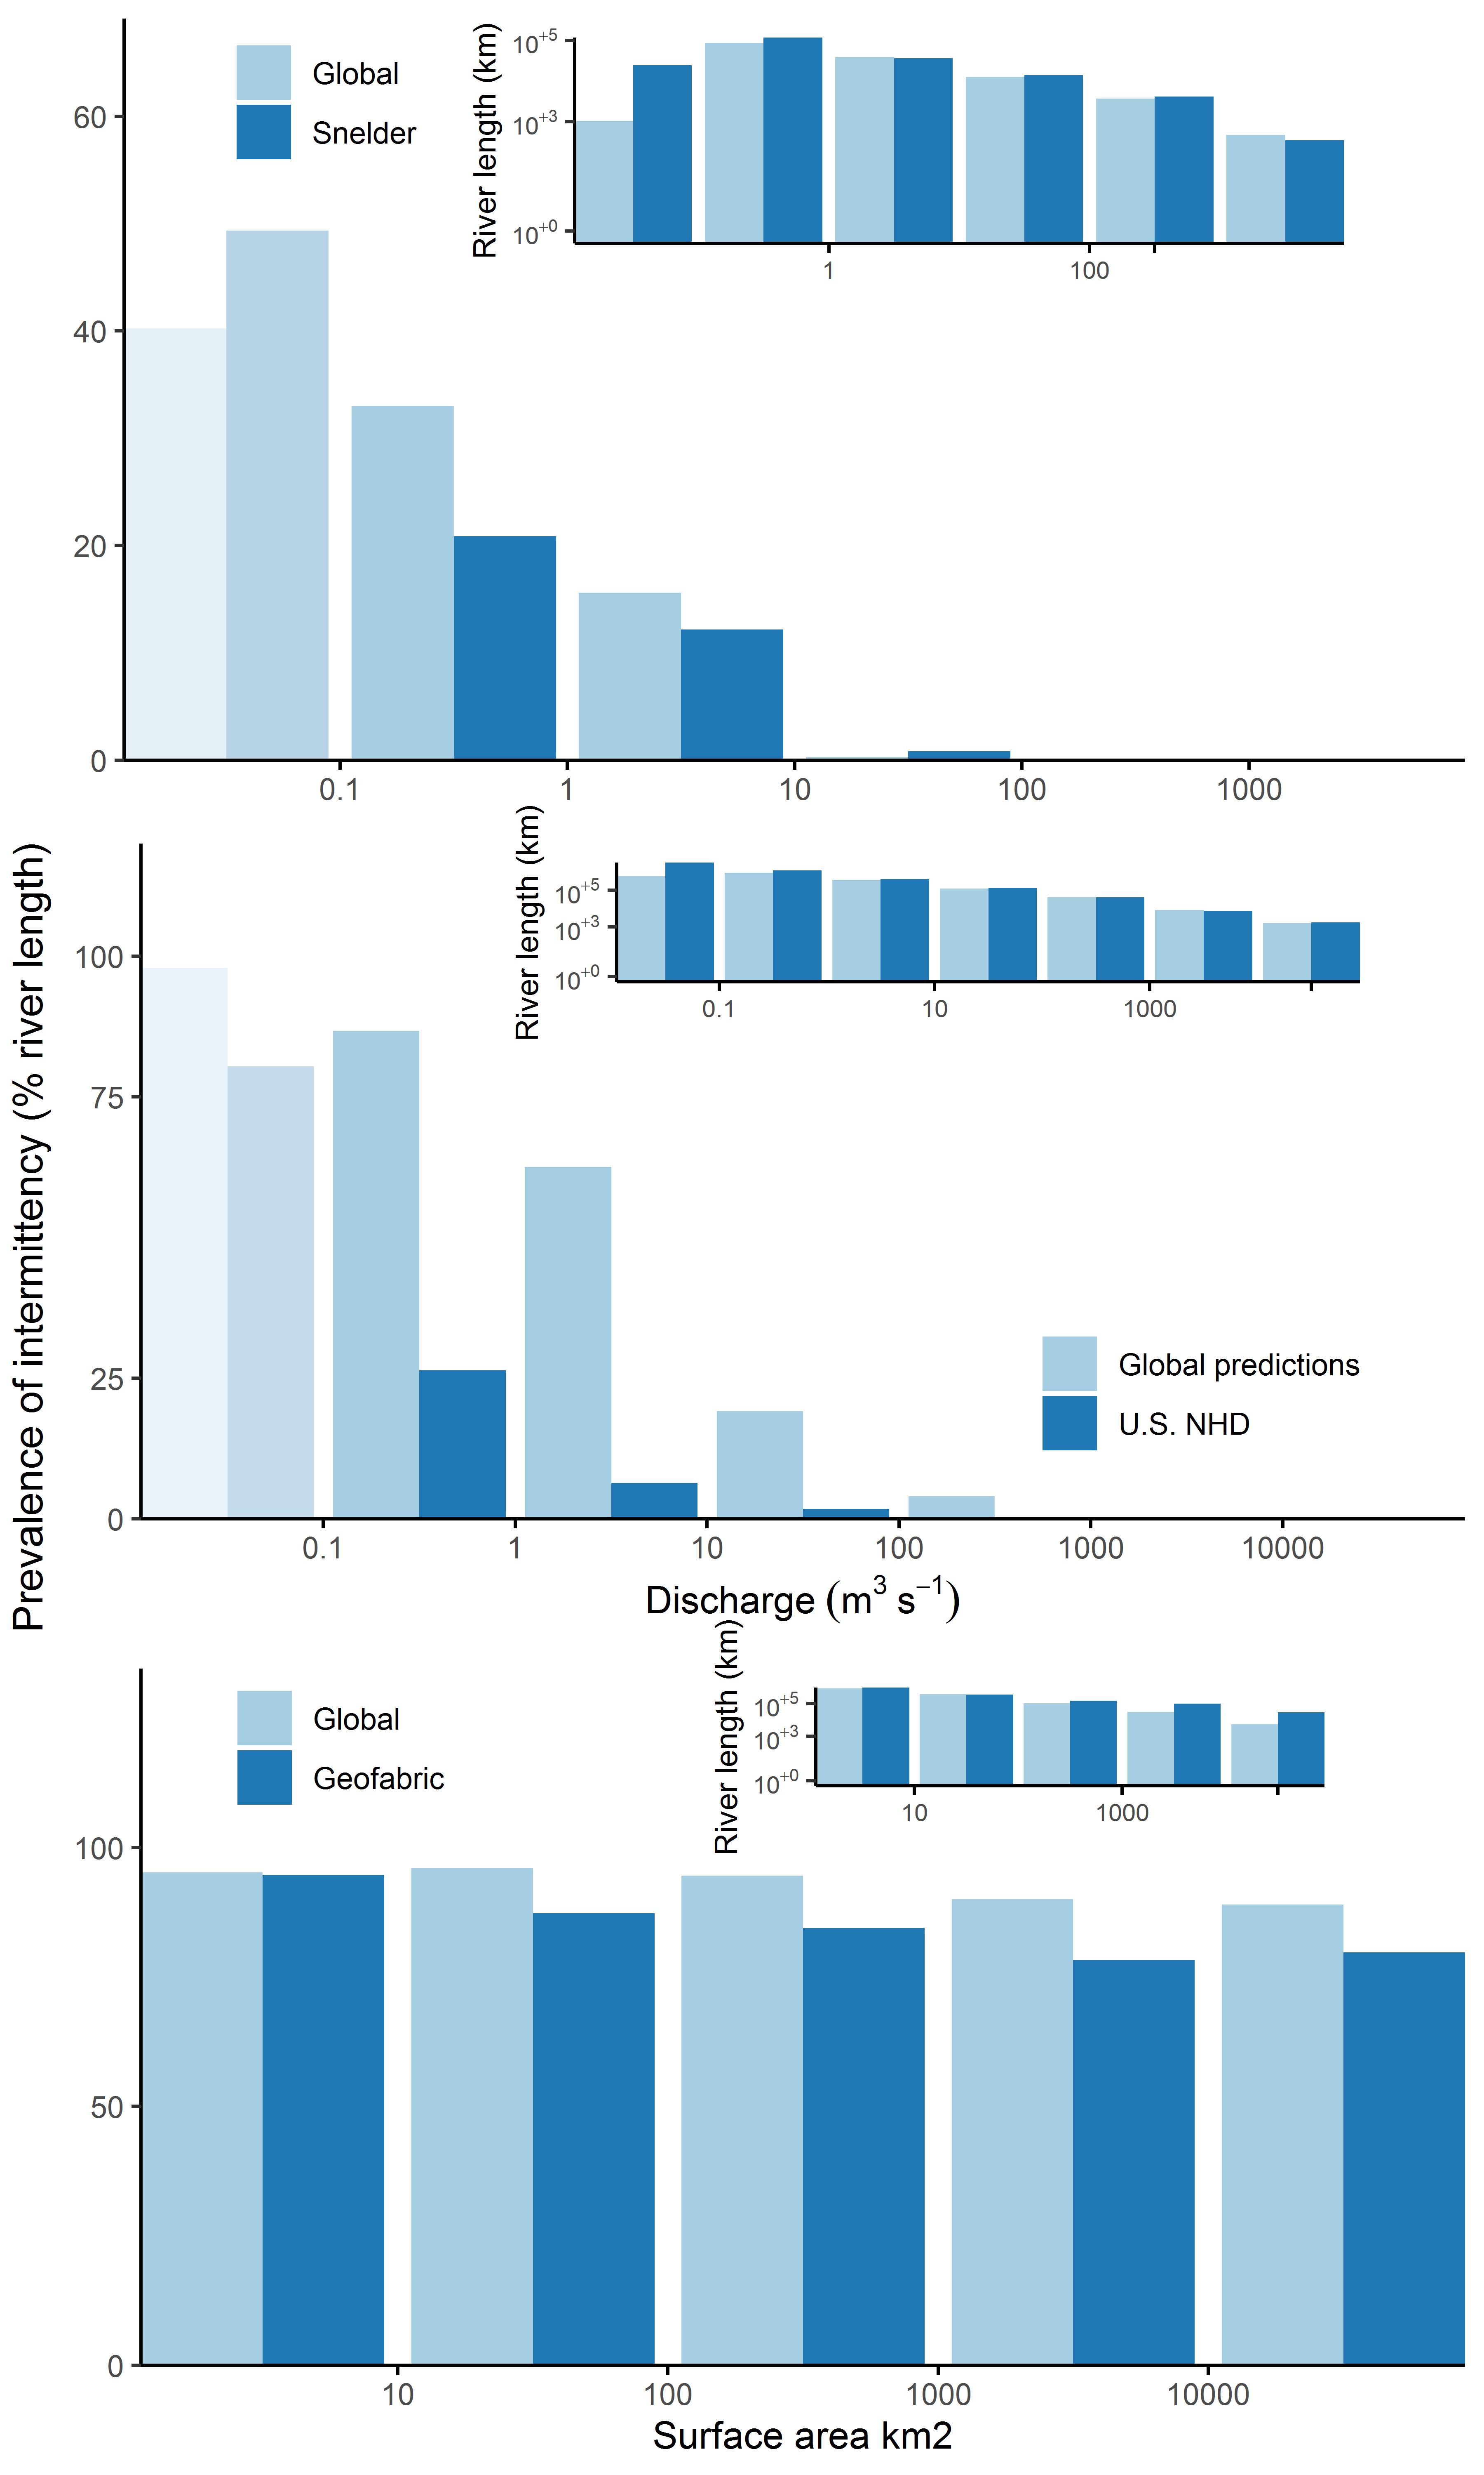

#Comparison of results with on-the-ground observations for PROSPER 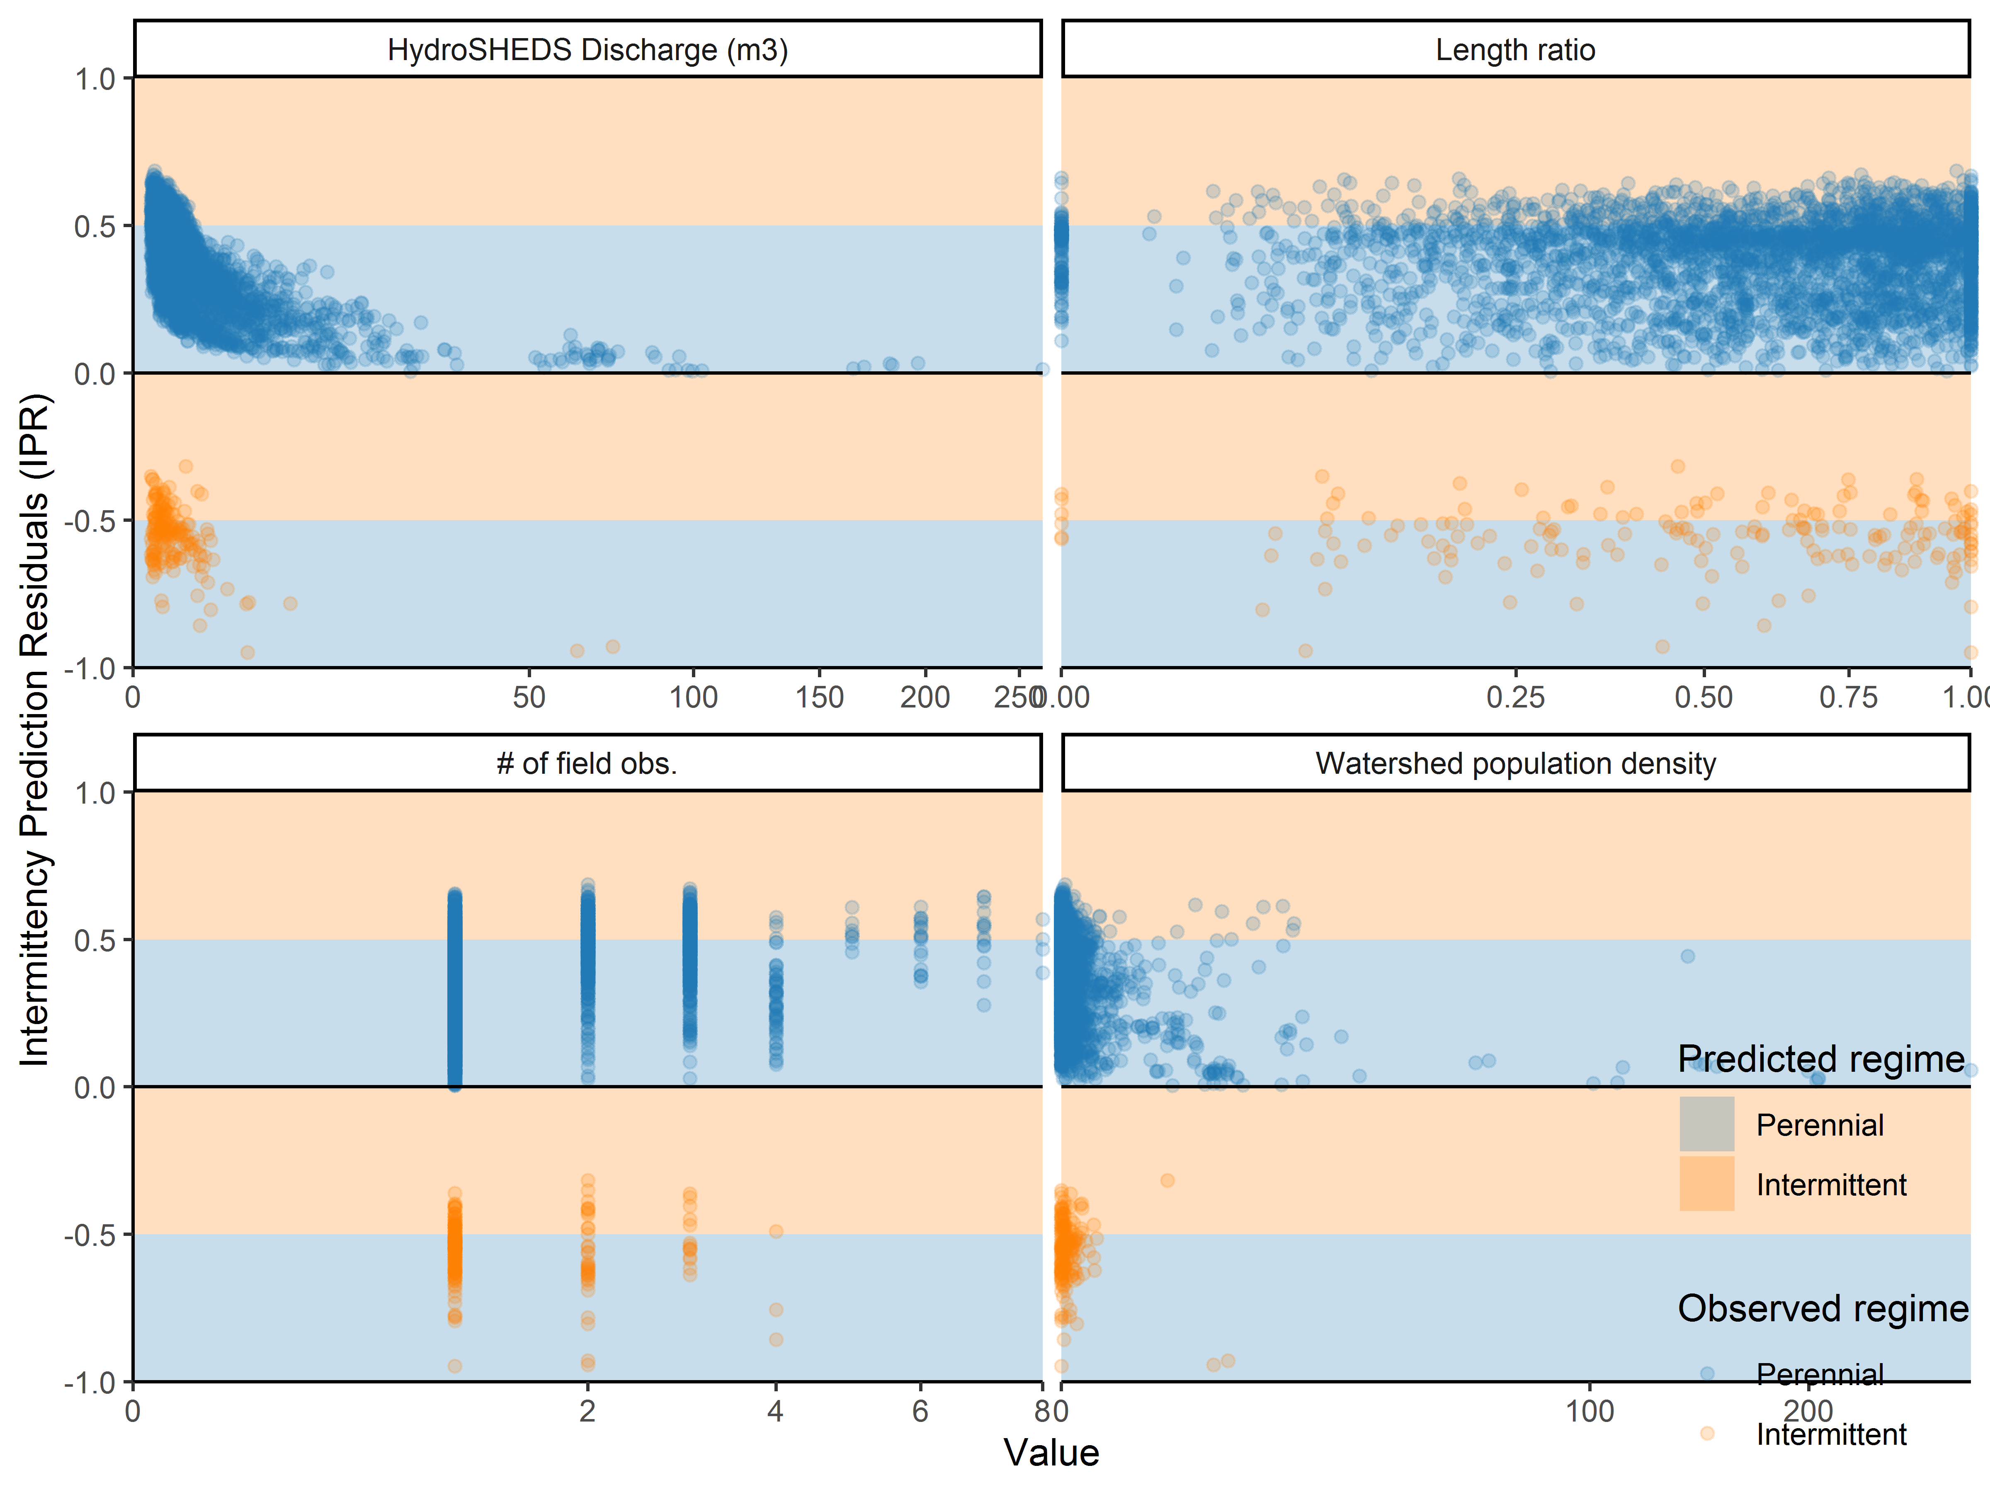

#Comparison of results with on-the-ground observations for ONDE 